overview
Key Points
- Nearly 400,000 new Ohio jobs: From 2011 to 2018, shale-related industry employment increased 7.8 percent, employing over 389,000 Ohioans. Average wages across the shale-related industries also increased to $98,613 – over $49,000 greater than the average for all industries in the state.
- A ban would cost 700,000 jobs: Ohio would lose an estimated 54,000 jobs in the upstream oil and gas industry from 2021-2025 if a hydraulic fracturing ban was put in place. Overall, By 2025, a hydraulic fracturing ban would cost Ohio 700,000 jobs.
- 700 new businesses and $78 Billion In Investments In Ohio: From 2011 to 2018, 700 new businesses have been established across Ohio to support the shale industry, bringing in over $63.9 billion in new investment. From 2011 to 2018, shale related investment in Ohio reached $78 billion.
- $40.2 billion in savings: Ohio natural gas consumers have saved over $40.2 billion between 2006 and 2016 simply as a result of the decreasing price of natural gas - with residential users saving almost $15 billion, while commercial and industrial users saved upwards of $25.3 billion.
- A ban would mean $5,625 in cost of living increases: A hydraulic fracturing ban would cost a residential consumer in Ohio $5,625 in the cumulative cost of living increases from 2021 to 2025.
- 14 times more production in 5 years: In 2018, natural gas production in Ohio increased by more than 14 times its 2013 level, rising from less than 0.6 percent to 5.5 percent of the nation’s total production during that period.
- 30 percent of the country’s gas supply: Ohio’s Appalachian Region currently produces 30 percent of the country’s natural gas supply, a growth of 900 percent since 2010.
- A ban would mean billions in losses for the Ohio economy: By 2025, a hydraulic fracturing ban would result in a $245 billion loss in gross domestic product, $119 billion loss in household incomes, $20.6 billion loss in state and local tax revenue for Ohio.
- A cleaner Ohio environment: Since 1990, Ohio’s emissions of key pollutants have decreased across the board, including a 16 percent reduction in CO2 emissions.
Natural Gas and jobs in ohio
Over The Last Several Years, Ohio Shale Jobs Increased 7.8 Percent, Employing Over 389,000 Ohioans With Salaries Well Above The State Average
From 2011 to 2018, shale-related industry employment increased 7.8 percent, employing over 389,000 Ohioans. “Beginning in 2011, the Ohio Department of Jobs and Family Services has been reporting on the economic trends with direct and indirect links to the oil and gas industry. In the seven years since this reporting began, shale-related industry employment increased 7.8 percent, employing over 389,000 Ohioans. Employment of Ohioans, however, does not tell the whole story.” (“The Benefits of Ohio’s Natural Gas Production to Energy Consumers and Job Creators,” Consumer Energy Alliance, 8/18)
“Average wages across the shale-related industries also increased to $98,613 – over $49,000 greater than the average for all industries in the state.” (“The Benefits of Ohio’s Natural Gas Production to Energy Consumers and Job Creators,” Consumer Energy Alliance, 8/18)
A Hydraulic Fracturing Ban Would Cost Ohio 700,000 Jobs By 2025
Ohio would lose an estimated 54,000 jobs in the upstream oil and gas industry from 2021-2025 if a hydraulic fracturing ban was put in place. “To better understand the influence that a ban on hydraulic fracturing would have on the economy, we first estimated the number of jobs that would be lost in the upstream oil and gas industry over a five-year period, focusing both on our seven target states (Ohio, Pennsylvania, Colorado, Texas, New Mexico, Michigan, and Wisconsin) and the U.S. economy writ large. As shown in Table 1, although the hemorrhaging of jobs would begin relatively slowly in 2021, the pace of losses picks up considerably as we approach 2025 and beyond, culminating in more than one million jobs lost just in the upstream oil and gas sector in 2025.” (“What If Hydraulic Fracturing Was Banned?,” U.S. Chamber of Commerce Global Energy Institute, 12/19, p. 32)
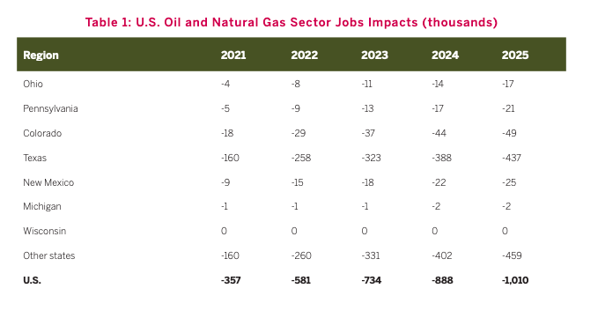
(“What If Hydraulic Fracturing Was Banned?,” U.S. Chamber of Commerce Global Energy Institute, 12/19, p. 32)
Overall, By 2025, a hydraulic fracturing ban would cost Ohio 700,000 jobs. “KEY FINDINGS (BY 2025) • Job Impacts (in 2025): -700,000 • GDP Impacts: -$245 Billion • Household Income Impacts: -$119 Billion • State and Local Tax Revenues Impacts: -$20.6 Billion • Federal Tax Revenues Impacts: -$56.6 billion • Cost-of-Living Increase (per capita): $5,625” (“What If Hydraulic Fracturing Was Banned?,” U.S. Chamber of Commerce Global Energy Institute, 12/19, p. 41)
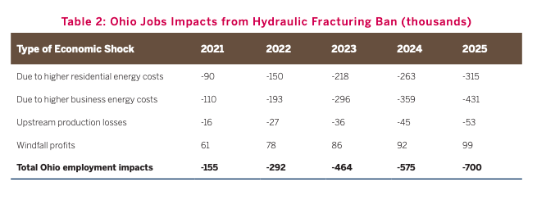
(“What If Hydraulic Fracturing Was Banned?,” U.S. Chamber of Commerce Global Energy Institute, 12/19, p. 43)
The Shale Industry Has Supported The Creation Of 700 New Businesses And $78 Billion In Investments In Ohio
From 2011 to 2018, 700 new businesses have been established across Ohio to support the shale industry, bringing in over $63.9 billion in new investment. “Meanwhile, with growth, new opportunities are born with Ohio experiencing a boom in business start-ups related to the shale industry which has created careers that provide family-sustaining wages. In this time, more than 700 new businesses have been established across the state to support the shale industry, bringing in over $63.9 billion in new investment.10 These businesses invested in all aspects of shale energy - from production and transmission, to end-use power generation, petrochemical plants, and plastic manufacturing. Many of these positions are coming back to parts of Ohio that were hit the hardest from manufacturing job losses. For example, the Vallourec Steel plant in Youngstown represented over $1 billion in new investment and brought hundreds of new steel jobs back to the Mahoning Valley for the first time in decades - all due to the abundance of low-cost natural gas and energy infrastructure.11” (“The Benefits of Ohio’s Natural Gas Production to Energy Consumers and Job Creators,” Consumer Energy Alliance, 8/18)
From 2011 to 2018, shale related investment in Ohio reached $78 billion. “Development of natural gas and liquids in eastern Ohio’s Utica and Marcellus Shale has revitalized the Buckeye State’s legacy oil industry as production has grown to record levels in recent years.10 Natural gas production eclipsed 2.4 trillion cubic feet last year. The rise in production has generated significant investment in development and related manufacturing. A Cleveland State University study found shale related investment in Ohio from 2011-18 reached $78 billion last year.11” (“What If Hydraulic Fracturing Was Banned?,” U.S. Chamber of Commerce Global Energy Institute, 12/19, p. 42)
Natural Gas Savings For Ohio Consumers
Low Cost Natural Gas Has Saved Ohio Consumers Over $40.2 Billion Between 2006 And 2016
Ohio natural gas consumers have saved over $40.2 billion between 2006 and 2016 simply as a result of the decreasing price of natural gas - with residential users saving almost $15 billion, while commercial and industrial users saved upwards of $25.3 billion. “Ohio is one of the top 10 natural gas consuming states in the nation with nearly two-thirds of residential consumers using natural gas for home heating.5 Prior to the shale revolution, prices for natural gas in Ohio peaked at $10.66 and has steadily decreased to just under $4. Due to increased production and new technologies, Ohio natural gas consumers have saved over $40.2 billion between 2006 and 2016 simply as a result of the decreasing price of natural gas - with residential users saving almost $15 billion, while commercial and industrial users saved upwards of $25.3 billion.6” (“The Benefits of Ohio’s Natural Gas Production to Energy Consumers and Job Creators,” Consumer Energy Alliance, 8/18)
A Hydraulic Fracturing Ban Would Cost A Residential Consumer In Ohio $5,625 From 2021 To 2025
A hydraulic fracturing ban would cost a residential consumer in Ohio $5,625 in the cumulative cost of living increases from 2021 to 2025. “Of particular note, due to the devastating economy-wide impacts of a fracking ban, residents in Michigan and Wisconsin would experience similar levels of hardship as those in energy-producing states. For instance, the cumulative cost of living increases for a residential consumer from 2021-2025 is almost as great in Michigan ($5,170) and Wisconsin ($4,777), as it is in Ohio ($5,625), Pennsylvania ($4,654), Colorado ($6,490), Texas ($7,280), and New Mexico ($5,790), demonstrating the impact of a fracking ban on manufacturing and the overall U.S. economy.” (Press Release, “New Chamber Analysis Quantifies Economic Risks Of Proposed Fracking Ban,” U.S. Chamber of Commerce Global Energy Institute, 12/19/19)
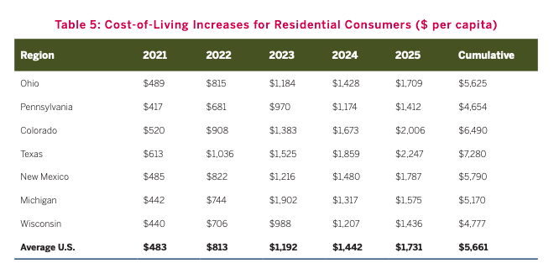
(“What If Hydraulic Fracturing Was Banned?,” U.S. Chamber of Commerce Global Energy Institute, 12/19, p. 35)
Natural Gas Benefits the ohio economy
In 2018, natural gas production in Ohio increased by more than 14 times its 2013 level, rising from less than 0.6 percent to 5.5 percent of the nation’s total production
In 2018, natural gas production in Ohio increased by more than 14 times its 2013 level, rising from less than 0.6 percent to 5.5 percent of the nation’s total production during that period. “In 2018, natural gas production in Ohio increased by more than 14 times its 2013 level, rising from less than 0.6 percent to 5.5 percent of the nation’s total production during that period.3” (“What If Hydraulic Fracturing Was Banned?,” U.S. Chamber of Commerce Global Energy Institute, 12/19, p. 42)
Natural gas used at Ohio’s electric power plants has increased markedly in the past 10 years and was almost 14 times greater in 2018 than in 2008. “Ohio is one of the 10 largest states by population and is among the top 10 total energy consuming states.4 Natural gas used at Ohio’s electric power plants has increased markedly in the past 10 years and was almost 14 times greater in 2018 than in 2008.15 The electric power sector is the state’s largest natural gas user, accounting for nearly 30 percent of total gas consumption, followed by residential customers who account for more than 25 percent.16” (“What If Hydraulic Fracturing Was Banned?,” U.S. Chamber of Commerce Global Energy Institute, 12/19, p. 42-43)
- The economic development agency JobsOhio lists about $1.5 billion worth of natural gas-fired power plant construction occurring in 2019. “The switch to natural gas for electricity has also spurred investments in new power plants in Ohio. The economic development agency JobsOhio lists about $1.5 billion worth of natural gas-fired power plant construction occurring in 2019.17” (“What If Hydraulic Fracturing Was Banned?,” U.S. Chamber of Commerce Global Energy Institute, 12/19, p. 42-43)
Due to hydraulic fracturing, Ohio’s natural gas production surpassed state consumption for the first time in 2015. “Ohio’s economy is on track to continue its expansion, with significant growth from oil and natural gas development in the Utica and Point Pleasant shale formations. The Utica formation holds large amounts of crude oil as well as wet natural gas, which can be processed to extract ethane, propane, and other natural gas liquids.7 Due to hydraulic fracturing, Ohio’s natural gas production surpassed state consumption for the first time in 2015.8,9” (“What If Hydraulic Fracturing Was Banned?,” U.S. Chamber of Commerce Global Energy Institute, 12/19, p. 42)
Ohio’s Appalachian Region Currently Produces 30 Percent Of The Country’s Natural Gas Supply, A Growth Of 900 Percent Since 2010
“Ohio’s Appalachian Region currently produces 30 percent of the country’s natural gas supply, a growth of 900 percent since 2010.” (“The Future for Natural Gas Production is in Ohio,” JobsOhio, Accessed 2/24/20)
- The Utica and Marcellus shale formations will supply nearly half of the nation’s natural gas and nearly a fifth of its natural gas liquids by 2040. “In the first study of its kind, IHS Markit determined that the Marcellus and Utica shale formations will supply nearly half of the nation’s natural gas and nearly a fifth of its natural gas liquids by 2040. The Marcellus and Utica shale formations have become a national center of natural gas and natural gas liquids production. This resource base will play a key role in satisfying America’s increasing reliance on natural gas, according to an IHS Markit study. The projected savings linked to processing natural gas liquids such as methane, propane and butane in the tri-state region of Ohio, Pennsylvania and West Virginia rather than the Gulf Coast are expected to range from 6 percent to 26 percent. The significant savings already is attracting investors’ attention and elevating the region’s investment profile.” (“Ohio Valley To Produce 45 Percent Of Nation’s Natural Gas,” JobsOhio, Accessed 2/24/20)
Natural gas used at Ohio’s electric power plants has increased markedly in the past 10 years and was almost 14 times greater in 2018 than in 2008. “Ohio is one of the 10 largest states by population and is among the top 10 total energy consuming states.4 Natural gas used at Ohio’s electric power plants has increased markedly in the past 10 years and was almost 14 times greater in 2018 than in 2008.15 The electric power sector is the state’s largest natural gas user, accounting for nearly 30 percent of total gas consumption, followed by residential customers who account for more than 25 percent.16” (“What If Hydraulic Fracturing Was Banned?,” U.S. Chamber of Commerce Global Energy Institute, 12/19, p. 42-43)
- The economic development agency JobsOhio lists about $1.5 billion worth of natural gas-fired power plant construction occurring in 2019. “The switch to natural gas for electricity has also spurred investments in new power plants in Ohio. The economic development agency JobsOhio lists about $1.5 billion worth of natural gas-fired power plant construction occurring in 2019.17” (“What If Hydraulic Fracturing Was Banned?,” U.S. Chamber of Commerce Global Energy Institute, 12/19, p. 42-43)
By 2025, A Hydraulic Fracturing Ban Would Result In A $245 Billion Loss In Gross Domestic Product, $119 Billion Loss In Household Incomes, $20.6 Billion Loss In State And Local Tax Revenue For Ohio
By 2025, a hydraulic fracturing ban would result in a $245 billion loss in gross domestic product for Ohio. “KEY FINDINGS (BY 2025) • Job Impacts (in 2025): -700,000 • GDP Impacts: -$245 Billion • Household Income Impacts: -$119 Billion • State and Local Tax Revenues Impacts: -$20.6 Billion • Federal Tax Revenues Impacts: -$56.6 billion • Cost-of-Living Increase (per capita): $5,625” (“What If Hydraulic Fracturing Was Banned?,” U.S. Chamber of Commerce Global Energy Institute, 12/19, p. 41)
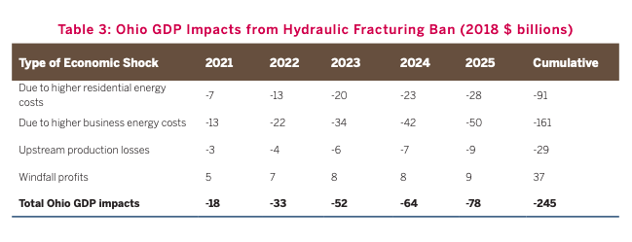
(“What If Hydraulic Fracturing Was Banned?,” U.S. Chamber of Commerce Global Energy Institute, 12/19, p. 44)
By 2025, a hydraulic fracturing ban would result in a $119 billion loss in household incomes for Ohio. “KEY FINDINGS (BY 2025) • Job Impacts (in 2025): -700,000 • GDP Impacts: -$245 Billion • Household Income Impacts: -$119 Billion • State and Local Tax Revenues Impacts: -$20.6 Billion • Federal Tax Revenues Impacts: -$56.6 billion • Cost-of-Living Increase (per capita): $5,625” (“What If Hydraulic Fracturing Was Banned?,” U.S. Chamber of Commerce Global Energy Institute, 12/19, p. 41)
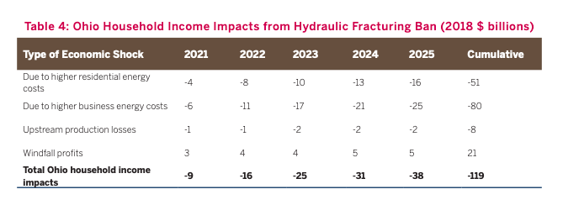
(“What If Hydraulic Fracturing Was Banned?,” U.S. Chamber of Commerce Global Energy Institute, 12/19, p. 44)
By 2025, a hydraulic fracturing ban would result in a $20.6 billion loss in state and local tax revenue and $56.6 billion loss in federal tax revenue for Ohio. “KEY FINDINGS (BY 2025) • Job Impacts (in 2025): -700,000 • GDP Impacts: -$245 Billion • Household Income Impacts: -$119 Billion • State and Local Tax Revenues Impacts: -$20.6 Billion • Federal Tax Revenues Impacts: -$56.6 billion • Cost-of-Living Increase (per capita): $5,625” (“What If Hydraulic Fracturing Was Banned?,” U.S. Chamber of Commerce Global Energy Institute, 12/19, p. 41)
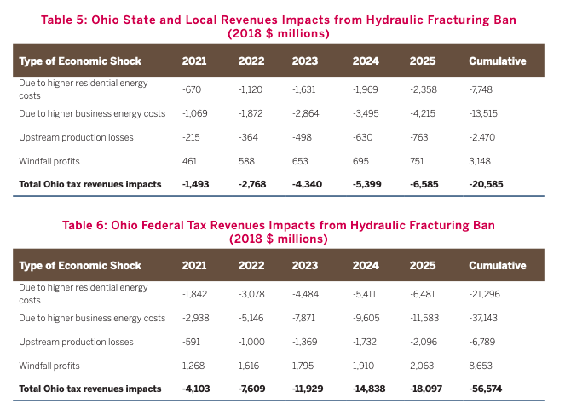
(“What If Hydraulic Fracturing Was Banned?,” U.S. Chamber of Commerce Global Energy Institute, 12/19, p. 44)
Contributing To A Cleaner Ohio Environment
Since 1990, Ohio’s Emissions Of Key Pollutants Have Decreased Across The Board, Including A 16 Percent Reduction In CO2 Emissions
Since 1990, Ohio’s emissions of key pollutants have decreased across the board, including a 16 percent reduction in CO2 emissions. "From 1990 to 2017, Ohio’s emissions of key pollutants have decreased across the board: • 72 percent reduction in nitrogen oxides (NOx) • 94 percent reduction in sulfur dioxide (SO2)• 74 percent reduction in carbon monoxide (CO) • 66 percent reduction in volatile organic compounds (VOCs) • 13 percent reduction in fine particulate matter (PM2.5) • 21 percent reduction in coarse particulate matter (PM10) • 23 percent reduction in ammonia (NH3). Additionally, from 1990 to 2016, Ohio’s carbon dioxide (CO2) emissions declined by 16 percent.” (“Ohio Emissions Analysis,” Consumer Energy Alliance, 9/19)
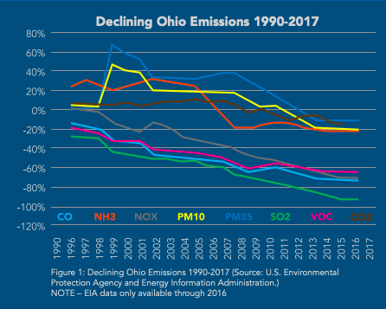
(“Ohio Emissions Analysis,” Consumer Energy Alliance, 9/19)

