Key Points
- A key ingredient: Natural gas provides the base ingredient for products like plastic, chemicals, fertilizer, anti-freeze, and fabrics.
- The chemical manufacturing is investing $202 billion in new plant capacity: The chemical manufacturing industry, the single largest industrial consumer of natural gas, has invested over $202 billion in new plant capacity, which is “is predicted to generate 786,000 direct and indirect jobs by 2025.”
- An affordable fuel source for the whole manufacturing sector: Increases in U.S. oil and gas production help to fuel growth in U.S. manufacturing jobs. Over the last decade, the surge in production from the shale revolution has helped create 1.4 million new manufacturing jobs for Americans.
- Reduces production costs for energy-intensive industries such as chemicals, metals, food, and refining: NAM Study: “For energy-intensive industries such as chemicals, metals, food, and refining, production costs have been reduced as a result of the increase in natural gas supply, and IHS expects these industries to outperform the U.S. economy as a whole through 2025.”
- Increased supply at low delivered prices is attractive to manufacturing activities that are large, and intensive users of NG such as chemicals, food, paper, and metals: NAM Study: “Increased supplies of NG, especially at lower delivered prices, enhances the competitiveness of economies by making them more attractive to manufacturing activities that are large, and intensive users of NG such as chemicals, food, paper, and metals.”
- Integral to the health care industry: Natural Gas is integral to the health care industry both as a heating source and a key ingredient in many health products.
- Fuels vehicles crucial to our supply chain: Some vehicles, especially many government and private vehicle fleets, are powered by natural gas—helping to keep the much-needed supply chain moving. Since 2016, shipping company UPS has operated more than 1,700 trucks fueled by natural gas and plans to purchase more than 6,000 through 2022.
Natural Gas Is An Ingredient In The Production Of Many Materials Like Plastics, Chemicals And Fertilizer
Natural gas provides the base ingredient for products like plastic, fertilizer, anti-freeze, and fabrics. “Natural gas has a multitude of industrial uses, including providing the base ingredients for such varied products as plastic, fertilizer, anti-freeze, and fabrics. In fact, industry is the largest consumer of natural gas, accounting for 43 percent of natural gas use across all sectors. Natural gas is the second most used energy source in industry, trailing only electricity. Lighting is the main use of energy in the industrial sector, which accounts for the tremendous electricity requirements of this sector. The graph below shows current as well as projected energy consumption by fuel in the industrial sector.” (“Uses In Industry,” NaturalGas.org, 9/20/13)
- Ethane, which is derived from natural gas is a key ingredient in making plastics. “Natural gas is mostly used for heating homes or fueling power plants. But when it comes out of the ground it contains another key ingredient — ethane, a building block of plastics — that is now fueling another booming industry. America is producing so much ethane that more than 300 new petrochemical and plastics plants are either planned or are under construction around the U.S. President Trump has touted the economic benefits of this, recently telling workers at a Shell ethane plant in Pennsylvania that ‘we are reclaiming our noble heritage as a nation of builders.” (Reid Frazier, “The U.S. Natural Gas Boom Is Fueling A Global Plastics Boom,” NPR, 11/15/19)
The industrial sector uses natural gas “as a raw material (feedstock) to produce chemicals, fertilizer, and hydrogen.” “The industrial sector uses natural gas as a fuel for process heating, in combined heat and power systems, and as a raw material (feedstock) to produce chemicals, fertilizer, and hydrogen. In 2018, the industrial sector accounted for about 33% of total U.S. natural gas consumption, and natural gas was the source of about 32% of the U.S. industrial sector's total energy consumption.” (“Natural gas explained,” U.S. Energy Information Administration, 12/18/19)
The Chemical Manufacturing Industry, The Single Largest Industrial Consumer Of Natural Gas, Has Invested Over $202 Billion In New Plant Capacity, Which Is “Is Predicted To Generate 786,000 Direct And Indirect Jobs By 2025”
According to the American Chemistry Council, “The chemical manufacturing industry, the single largest industrial consumer of natural gas, has invested over $202 billion in new plant capacity, in part because of the industry’s ability to access cheap gas, which has created a competitive advantage for the U.S. manufacturing sector.” “The chemical manufacturing industry, the single largest industrial consumer of natural gas, has invested over $202 billion in new plant capacity, in part because of the industry’s ability to access cheap gas, which has created a competitive advantage for the U.S. manufacturing sector.” (American Gas Association, et al, Letter to Members of the United States House of Representatives Committee on Energy & Commerce Subcommittee on Energy, 2/3/20)
- “This has created $292 billion in new economic output and is predicted to generate 786,000 direct and indirect jobs by 2025.” “This has created $292 billion in new economic output and is predicted to generate 786,000 direct and indirect jobs by 2025, according to the American Chemistry Council.” (American Gas Association, et al, Letter to Members of the United States House of Representatives Committee on Energy & Commerce Subcommittee on Energy, 2/3/20)
Natural Gas Fuels Jobs In The Manufacturing Sector As An Affordable And Abundant Energy Source
From the mid 1970s to the early 2000s, U.S. oil and gas production declined and nearly three million manufacturing jobs were lost. And, another five million manufacturing jobs were lost when China joined the World Trade Organization in 2001. (U.S. Energy Information Administration, Accessed 8/31/20; Federal Reserve Bank of St. Louis, Accessed 8/31/20)
In contrast, increases in U.S. oil and gas production help to fuel growth in U.S. manufacturing jobs. Over the last decade, the surge in production from the shale revolution has helped create 1.4 million new manufacturing jobs for Americans. (U.S. Energy Information Administration, Accessed 8/31/20; Federal Reserve Bank of St. Louis, Accessed 8/31/20)
According to the National Association of Manufacturers, “for every one worker in manufacturing, there are another five employees hired elsewhere.” “For every $1.00 spent in manufacturing, another $2.74 is added to the economy. That is the highest multiplier effect of any economic sector. In addition, for every one worker in manufacturing, there are another five employees hired elsewhere. (Source: NAM calculations using 2018 IMPLAN data.) With that said, recent research suggests that manufacturing’s impacts on the economy are even larger than that if we consider the entire manufacturing value chain plus manufacturing for other industries’ supply chains. That approach estimates that manufacturing could account for one-third of GDP and employment. Along those lines, it also estimated the total multiplier effect for manufacturing to be $3.60 for every $1.00 of value-added output, with one manufacturing employee generating another 3.4 workers elsewhere.” (“Facts About Manufacturing,” National Association of Manufacturers, Accessed 9/3/20)
A National Association of Manufacturers’ study estimated that in 2015, “economic benefits from increased domestic shale gas production and the accompanying lower NG prices include contributions of $190 billion to real gross domestic product (GDP), 1.4 million additional jobs, and $156 billion to real disposable income.” “The U.S. economy experienced significant gains in 2015: IHS estimates that economic benefits from increased domestic shale gas production and the accompanying lower NG prices include contributions of $190 billion to real gross domestic product (GDP), 1.4 million additional jobs, and $156 billion to real disposable income.” (“Natural Gas Study: Energizing Manufacturing,” National Association of Manufacturers, 5/16)
NAM Study: “For energy-intensive industries such as chemicals, metals, food, and refining, production costs have been reduced as a result of the increase in natural gas supply, and IHS expects these industries to outperform the U.S. economy as a whole through 2025.” “Well-understood economic contributions are derived from midstream and downstream energy capital and O&M expenditures across a diverse supply chain. Recent IHS analyses on the U.S. ‘manufacturing renaissance’ identified clear competitive advantages that have emerged for manufacturing in America as a result of the increased supply of competitively priced natural gas. For energy-intensive industries such as chemicals, metals, food, and refining, production costs have been reduced as a result of the increase in natural gas supply, and IHS expects these industries to outperform the U.S. economy as a whole through 2025.” (“Natural Gas Study: Energizing Manufacturing,” National Association of Manufacturers, 5/16)
NAM Study: “Increased supplies of NG, especially at lower delivered prices, enhances the competitiveness of economies by making them more attractive to manufacturing activities that are large, and intensive users of NG such as chemicals, food, paper, and metals.” “The improved competitive positioning of industries in the manufacturing sector is shaping state and local economic development strategies across the country. Increased supplies of NG, especially at lower delivered prices, enhances the competitiveness of economies by making them more attractive to manufacturing activities that are large, and intensive users of NG such as chemicals, food, paper, and metals. The close proximity of existing clusters of manufacturing establishments to increased NG supplies can generate new pipeline-related economic development, often because of the availability of direct connections to a new or expanded NG pipeline.” (“Natural Gas Study: Energizing Manufacturing,” National Association of Manufacturers, 5/16)
Natural Gas Is Integral To The Health Care Industry Both As A Heating Source And A Key Ingredient In Many Health Products
“Plastics derived from natural gas go into items like MRIs, IV bags and tubes, lights, monitors, stethoscopes, prosthetics, and hearing aids.” “Oil and natural gas not only fuel our economy, they provide the basic materials for making health care products that save lives and keep us healthy. Step into a hospital or clinic, and you’re surrounded by objects that come from petroleum. Plastics derived from natural gas go into items like MRIs, IV bags and tubes, lights, monitors, stethoscopes, prosthetics, and hearing aids. Chemicals derived from petroleum become soaps, antiseptics, aspirin, and pharmaceuticals.” (Sean Hackbarth, “Infographic: Health Care Would Be In A World Of Hurt Without Petroleum,” U.S. Chamber of Commerce, 4/29/16)
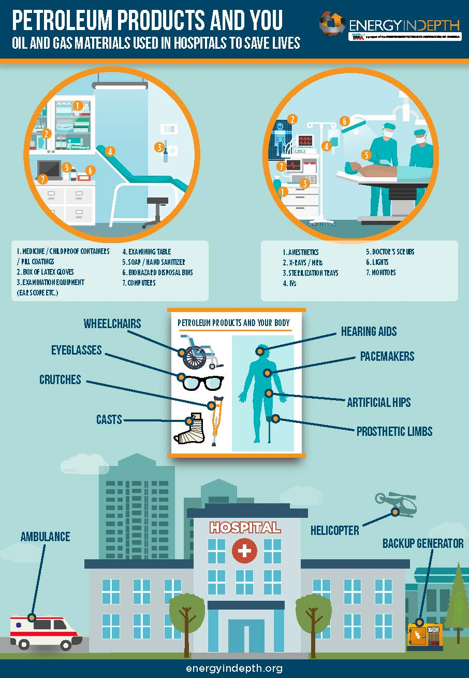
(Priyanka Deo, “Petroleum Products And You: Oil And Gas Materials Used In Hospitals To Save Lives,” Energy In Depth, 3/30/16)
Natural gas is the most used energy source in large hospitals for both space and water heating, as well as cooking. “In large hospitals, natural gas was the most used space heating and water heating fuel. Large hospital buildings in 2007 consumed a total of 458 trillion Btu in major fuels: 208 trillion Btu of natural gas, 194 trillion Btu of electricity, 6 trillion Btu of fuel oil, and 49 trillion Btu of district heat 2. The major fuel intensity was 234,100 Btu per square foot of floorspace. As shown in Figure 1, natural gas was the most common main space heating fuel, used by 74 percent of the buildings, followed by district heat, 20 percent. All buildings had air conditioning and nearly all, 92 percent, used electricity to power air conditioning equipment. Water heating was also used in all buildings and had fuel use percentages similar to space heating: 74 percent used natural gas and 18 percent used district heat. Cooking was reported in 95 percent of the buildings, with natural gas and electricity the most common cooking fuels. Because of their need for a secure, reliable source of electricity, almost all large hospitals (95 percent) generated electricity, primarily for emergency back-up generation. Fuel oil was by far the most common generation fuel.” (“Energy Characteristics and Energy Consumed in Large Hospital Buildings in the United States in 2007,” U.S. Energy Information Administration, 8/17/12)
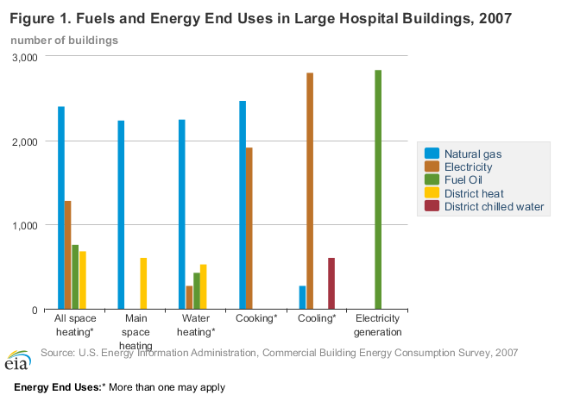
(“Energy Characteristics and Energy Consumed in Large Hospital Buildings in the United States in 2007,” U.S. Energy Information Administration, 8/17/12)
According to the 2007 Commercial Buildings Energy Consumption Survey (CBECS), 74% of large hospitals use natural gas for space and water heating. “Large hospitals consumed 458 trillion British thermal units, about 5.5% of the total delivered energy used by the commercial sector in 2007, a much larger share than their percentage of total commercial floorspace. EIA recently released data from the 2007 Commercial Buildings Energy Consumption Survey (CBECS) that highlights large hospitals' energy-related characteristics for all major fuels: electricity, natural gas, fuel oil, and district heat. Large hospitals are those over 200,000 square feet. In 2007, there were approximately 3,040 large hospital buildings in the United States, with an average of 640,000 square feet per building. Based on data from past CBECS, hospitals tend to consume more energy per square foot than other buildings in the commercial sector, such as offices, retail stores, or educational buildings. They are open 24 hours a day; occupied by thousands of employees, patients, and visitors; and often employ sophisticated heating, ventilation, and air conditioning (HVAC) systems to control temperatures and air flow. In addition, many energy-intensive activities occur in these buildings: laundry, medical and lab equipment use, sterilization, computer and server use, food service, and refrigeration. Not surprisingly, most of these energy-intensive buildings had energy management and conservation plans in place, and used technology and products to save energy. As shown in the graph above, natural gas was the most common main space heating fuel, used by 74% of the buildings, followed by district heat, or steam or hot water from an outside source, which was the main heating source for 20% of large hospitals. All hospital buildings had cooling (air conditioning) and almost all, 92%, used electricity to power cooling equipment. Water heating was also used in all hospital buildings and had fuel-use percentages similar to space heating: 74% natural gas and 19% district heat. Cooking was reported in 95% of the hospital buildings, with natural gas and electricity the most common cooking fuels. Because of their need for a secure reliable source of electricity, almost all large hospitals (95%) used energy for generating electricity, primarily for emergency back-up generation. Fuel oil was by far the most common fuel used for this purpose. For the first time in its 30-year history, the CBECS also collected data on water use. Large hospital buildings in the United States consumed an estimated 133 billion gallons of water in 2007, totaling $615 million in water expenditures, with an average of 43.6 million gallons and $202,200 per building.” (“Large hospitals tend to be energy-intensive,” U.S. Energy Information Administration, 8/23/12)
Natural Gas Fuels Vehicles Crucial To Our Supply Chain
Some vehicles, especially many government and private vehicle fleets, are powered by natural gas—helping to keep the much-needed supply chain moving. “The transportation sector uses natural gas as a fuel to operate compressors that move natural gas through pipelines and as a vehicle fuel in the form of compressed natural gas and liquefied natural gas. Nearly all vehicles that use natural gas as a fuel are in government and private vehicle fleets. In 2018, the transportation sector accounted for about 3% of total U.S. natural gas consumption. Natural gas was the source of about 3% of the U.S. transportation sector's total energy consumption in 2018, of which 95% was for natural gas pipeline and distribution operations.” (“Natural gas explained,” U.S. Energy Information Administration, 12/18/19)
- Natural gas powers more than 175,000 vehicles in the United States and roughly 23 million vehicles worldwide. “Natural gas powers more than 175,000 vehicles in the United States and roughly 23 million vehicles worldwide. Natural gas vehicles (NGVs) are good choices for high-mileage, centrally fueled fleets because they can provide similar fuel range support for applications not involved in long-haul routes where fuel stations can become sparse. For vehicles that travel long distances, liquefied natural gas (LNG) is a good choice as LNG has a greater energy density than CNG, meaning the fuel range is more comparable to conventional fuel. The advantages of natural gas as a transportation fuel include its domestic availability, widespread distribution infrastructure, and reduced greenhouse gas emissions over conventional gasoline and diesel fuels.” (“Natural Gas Vehicles,” U.S Department Of Energy Alternative Fuels Data Center, Accessed 3/24/20)
Since 2016, shipping company UPS has operated more than 1,700 trucks fueled by natural gas. “Since 2016, Agility Fuel Solutions has provided natural gas fuel storage and delivery systems to more than 1,700 UPS trucks. As part of the new agreement, Agility will provide complete end-to-end natural gas systems for heavy-duty gas trucks, terminal tractors and medium-duty walk-in vans, which are UPS’s familiar brown delivery trucks. These will include on-board CNG fuel storage and management and Agility’s certified natural gas engine fuel systems. ‘We are proud to continue our collaboration with UPS, a front-runner in clean transportation,’ says Seung Baik, president of Agility Fuel Solutions. ‘With our range of proven and reliable clean fuel technologies and aftermarket support capabilities, we will assist UPS in reaching its sustainability targets.’ Over the past decade, UPS has invested more than $1 billion in alternative fuel and advanced technology vehicles and fueling stations to help meet its target of reducing absolute greenhouse gas emissions by 12% across its global ground operations by 2025. UPS has continued its relationship with TruStar Energy to design, manufacture and install five new CNG fueling stations in Lathrop, Visalia and Moreno Valley, Calif., Houston, Texas, and Cleveland, Ohio. UPS will deploy the new CNG vehicles on routes to utilize the new CNG stations as well as adding to existing natural gas fleets in other UPS locations.” (Press Release, “UPS To Add More Than 6,000 Vehicles To Its Natural Gas Fleet,” UPS, 10/9/19)
In October 2019, UPS announced it would purchase more than 6,000 natural gas-powered trucks beginning in 2020 and running through 2022. “UPS (NYSE: UPS) today announced plans to purchase more than 6,000 natural gas-powered trucks beginning in 2020 and running through 2022. This three-year commitment represents a $450M investment in expanding the company’s alternative fuel and advanced technology vehicle fleet as well as supporting infrastructure. The new vehicles will be equipped with compressed natural gas (CNG) fuel systems provided under an exclusive agreement with Agility Fuel Solutions, a business of Hexagon Composites. The investment in CNG fuel systems expands UPS’s relationship with Agility Fuel Solutions and supports UPS’s fleet sustainability efforts. It will help reduce UPS’s carbon footprint and is expected to have a positive influence on national CNG market growth. The CNG fleet expansion also provides additional capacity for expanding the use of renewable natural gas (RNG). ‘UPS continues to expand and improve our smart logistics network by implementing new technologies and creating a highly flexible, data-driven, and sustainable network,’ said Juan Perez, chief information and engineering officer, UPS. ‘That is why we intend for 25 percent of our vehicles purchased in 2020 to run on alternative fuels.’” (Press Release, “UPS To Add More Than 6,000 Vehicles To Its Natural Gas Fleet,” UPS, 10/9/19)
UPS “has agreed to purchase 230 million gallon equivalents of RNG [Renewable Natural Gas] over the next seven years, making the company the largest consumer of RNG in the transportation industry.” “Vehicles equipped with CNG fuel systems can interchangeably use RNG and conventional natural gas. Produced from landfills, dairy farms and other bio sources, RNG yields up to a 90 percent reduction in lifecycle greenhouse gas emissions when compared to conventional diesel. As of October 2019, UPS has agreed to purchase 230 million gallon equivalents of RNG over the next seven years, making the company the largest consumer of RNG in the transportation industry.” (Press Release, “UPS To Add More Than 6,000 Vehicles To Its Natural Gas Fleet,” UPS, 10/9/19)
“By the end of 2019, UPS will be operating 61 natural gas fueling stations strategically located across the U.S., and outside the U.S. in Vancouver, Canada, and Tamworth, United Kingdom.” (Press Release, “UPS To Add More Than 6,000 Vehicles To Its Natural Gas Fleet,” UPS, 10/9/19)

