overview
Executive Summary
In a February 2020 letter to Congress, the American Gas Association and other organizations wrote, “Energy is the capacity to do work.” Nothing exemplifies this statement quite like the opportunities provided by abundant, low-cost, domestic natural gas.
According to the American Gas Association, the natural gas industry supports 4.1 million U.S. jobs. But, that isn’t where the jobs end. Historically, American manufacturing jobs grow as natural gas production increases. From the mid 1970s to the early 2000s, U.S. oil and gas production declined and nearly three million manufacturing jobs were lost. However, over the last decade, the surge in production from the shale revolution has helped create 1.4 million new manufacturing jobs for Americans.
The oil and gas energy supply chain made up of “120,000+ companies, of which at least 100,000 are small businesses” also illustrates the cumulative effect oil and gas production has on job growth. For each one worker at the oil and gas production level there are three workers in the energy supply chain and six more in the induced economy like retail, hospitality, housing, and other services.
And, oil and gas jobs deliver not just quantity but quality. A July 2020 study by North America's Building Trades Unions (NABTU), found that oil and gas jobs “have better wages, benefits and opportunities than renewables projects.” The oil and gas industry provides an average annual salary of $108,000 and it is estimated that a worker would face a 50% or 75% pay cut to change jobs into the renewable industry. The oil and gas industry also creates jobs that are safer and closer to home for workers.
For Americans across the job spectrum, natural gas is literally the capacity to do work.
Key Points
“Energy Is The Capacity To Do Work” and Natural gas Is That Energy
- Natural gas supports over 4 million jobs: According to the American Gas Association, the natural gas industry supports 4.1 million U.S. jobs.
- Natural gas saves businesses money that can be invested in job creation: The natural gas industry has resulted in $121 billion in savings for U.S. businesses since 2009, allowing them to invest more in growth and job creation.
- “Energy is the capacity to do work”: American Gas Association in a letter to congressional members: “Energy is the capacity to do work … Newfound energy abundance in the United States has driven sustained economic growth over the last decade.”
- Natural gas development contributed to $87 billion in income: From 2013 to 2018, natural gas development generated approximately 730,000 more jobs that contributed $87 billion more in annual disposable income.
- 58 jobs for every mile of pipeline: There are 58 jobs for every mile of new transmission pipeline built and the United States will need an additional 26,000 miles of natural gas transmission infrastructure—more than $150 billion in investment—between 2018 and 2035.
NATURAL GAS FUELS JOBS IN THE MANUFACTURING SECTOR And Beyond
- Manufacturing jobs grow with increased natural gas production: From the mid 1970s to the early 2000s, U.S. oil and gas production declined and nearly three million manufacturing jobs were lost. However, over the last decade, the surge in production from the shale revolution has helped create 1.4 million new manufacturing jobs for Americans.
- More manufacturing jobs means five times as many jobs elsewhere: According to the National Association of Manufacturers, “for every one worker in manufacturing, there are another five employees hired elsewhere.”
- Increased access to natural gas and pipelines meant 1.9 million jobs in 2015 alone: A 2016 study by the National Association of Manufacturers (NAM) found “the combination of increased access to shale gas and the transmission lines that move that affordable energy to manufacturers across America meant 1.9 million jobs in 2015 alone.”
- Construction of 6,028 miles of new gas pipelines, resulted in an increase of 347,788 jobs in 2015: In 2015 alone, construction of 6,028 miles of new natural gas transmission pipelines, resulted “in a temporary increase in employment of 347,788 jobs, with 59,874 in the manufacturing sector.”
- The chemical manufacturing industry, the single largest industrial consumer of natural gas, could generate 786,000 jobs by 2025 because of savings from low-cost natural gas: The chemical manufacturing industry, the single largest industrial consumer of natural gas, has invested over $202 billion in new plant capacity, in part because of the industry’s ability to access cheap gas and is predicted to generate 786,000 direct and indirect jobs by 2025.
JOBS FLOW FROM THE OIL AND GAS ENERGY SUPPLY CHAIN
- [CHART] Energy supply chain workers make gas and oil operations work: The oil and gas energy supply chain is made up of “120,000+ companies, of which at least 100,000 are small businesses” … “and workers that produce and supply the equipment, construction, materials, services, logistics and technology used in oil and gas production and operations.”
- From truck drivers to administration to architects: Trades and professions that work in the oil and gas energy supply chain include: factory and warehouse; construction; equipment operators, truck drivers and mechanics; welders and ironworkers; technicians, maintenance and administrative workers; and professionals fields like engineers, scientific, architects, and financial.
- 750,000 jobs by 2025: The oil and gas energy supply chain employs over 600,000 workers with potential growth to over 750,000 by 2025.
- An average annual income of $79,000: Workers in the oil and gas energy supply chain earn an average annual income of $79,000. Shale energy supply chain workers' total incomes will grow from a total of $41 billion in 2012 to close to $60 billion in 2025.
- Linking more jobs to oil and gas production: For each one worker at the oil and gas production level there are three workers in the energy supply chain and six more in the induced economy like retail, hospitality, housing, and other services.
OIL AND GAS JOBS PROVIDE MOre ADVANTAGES FOR WORKERS Than Renewables
- [CHART] Better Wages, Benefits And Opportunities Than Renewables Projects”: A July 2020 study by North America's Building Trades Unions (NABTU), found that oil and gas jobs “have better wages, benefits and opportunities than renewables projects.”
- [CHART] Steadier Incomes And More Consistent Benefits Than Renewables Projects: Workers reported that oil and gas jobs were longer-term, resulting in steadier incomes and more consistent benefits. “‘With solar, you work your way out of a job. … Three months duration [then] you’re done,’ explained one electrician.”
- The oil and gas industry provides an average annual salary of $108,000: According to the Bureau of Labor Statistics the oil and gas industry provides an average annual salary of $108,000, “nearly twice the private economy average” and can be even higher at large companies like Exxon Mobil, where median worker pay is about $170,000 a year.
- A 50% to 75% pay cut to change jobs into the renewable industry: North America's Building Trades Unions (NABTU) president Sean McGarvey estimates that many union members would “take a 50% or 75% pay cut” if they changed jobs into the renewable energy industry.
- [CHART] Skilled trade jobs are not highly interchangeable between the industries: NABTU Studies: “Many of the trades that work on oil and natural gas projects are not as prevalent on renewables projects, indicating that skilled trade jobs are not highly interchangeable between industries.”
- [CHART] Oil and gas workers are safer: NABTU Studies: “The oil and natural gas industry’s reliance on registered apprenticeship and strict industry safety standards and procedures make workers safer in this segment of the construction industry.”
- [CHART] Jobs closer to home: NABTU Studies: “A mature industry infrastructure such as that in oil and gas is likely to allow more skilled tradespeople the opportunity to work in the energy sector while remaining closer to their homes and families.”
- Solid jobs for high school grads: NABTU Studies: “The construction and oil & natural gas industries rely heavily on high school graduates to staff about 45 percent of all the jobs in these two industries. Relative to many other high school graduates with no college education, high school graduates in construction, oil & natural gas are paid better while receiving more health insurance and pension coverage.”

“Energy Is The Capacity To Do Work” and Natural gas is that energy
The Natural Gas Industry Supports 4.1 Million U.S. Jobs
According to the American Gas Association, the natural gas industry supports 4.1 million U.S. jobs. (“Natural Gas Act Offers Clear Pathway to American Energy Abundance,” American Gas Association, 2/5/20)
The natural gas industry has resulted in $121 billion in savings for U.S. businesses since 2009, allowing them to invest more in growth and job creation. (“Natural Gas Act Offers Clear Pathway to American Energy Abundance,” American Gas Association, 2/5/20)
American Gas Association in a letter to congressional members: “Energy is the capacity to do work … Newfound energy abundance in the United States has driven sustained economic growth over the last decade.” “As organizations representing the natural gas value chain, we are writing to express our support for sound federal policy that facilitates the continued development of natural gas infrastructure. Energy is the capacity to do work. Without it, everything stops. When it is expensive, families spend and travel less. When it is unreliable, households, communities, and businesses cannot effectively plan. Newfound energy abundance in the United States has driven sustained economic growth over the last decade.” (American Gas Association, et al, Letter to Members of the United States House of Representatives Committee on Energy & Commerce Subcommittee on Energy, 2/3/20)
- “Over the past decade, America’s energy infrastructure companies have created hundreds of thousands of jobs, invested billions in communities, and made it more affordable for American families to heat their homes and cook their food.” “Over the past decade, America’s energy infrastructure companies have created hundreds of thousands of jobs, invested billions in communities, and made it more affordable for American families to heat their homes and cook their food. According to the White House Council of Economic Advisors, thanks to affordable natural gas, a family of four now enjoys approximately $2,500 in annual savings.” (American Gas Association, et al, Letter to Members of the United States House of Representatives Committee on Energy & Commerce Subcommittee on Energy, 2/3/20)
From 2013 to 2018, natural gas development generated $101 billion in real gross domestic product (GDP) growth each year, resulting in approximately 730,000 more jobs that contributed $87 billion more in annual disposable income. “Abundant natural gas has benefitted the nation’s economy. According to the National Association of Manufacturers, between 2013-2018, natural gas development generated $101 billion in real gross domestic product (GDP) growth each year, resulting in approximately 730,000 more American jobs that contributed $87 billion more in annual disposable income.” (American Gas Association, et al, Letter to Members of the United States House of Representatives Committee on Energy & Commerce Subcommittee on Energy, 2/3/20)
In addition, “infrastructure buildout itself creates opportunities for America’s skilled trade workers; there are 58 jobs for every mile of new transmission pipeline built.” (American Gas Association, et al, Letter to Members of the United States House of Representatives Committee on Energy & Commerce Subcommittee on Energy, 2/3/20)
- “To continue fully realizing the benefits of America’s natural gas abundance … the United States will need an additional 26,000 miles of natural gas transmission infrastructure—more than $150 billion in investment—between 2018 and 2035.” “To continue fully realizing the benefits of America’s natural gas abundance, additional energy infrastructure is needed. According to ICF International, the United States will need an additional 26,000 miles of natural gas transmission infrastructure—more than $150 billion in investment—between 2018 and 2035.” (American Gas Association, et al, Letter to Members of the United States House of Representatives Committee on Energy & Commerce Subcommittee on Energy, 2/3/20)
Natural gas Fuels Jobs in the manufacturing sector And beyond
After Decades Of Decline, The Surge In Production From The Shale Revolution Has Helped Create 1.4 Million New Manufacturing Jobs For Americans
From the mid 1970s to the early 2000s, U.S. oil and gas production declined and nearly three million manufacturing jobs were lost. And, another five million manufacturing jobs were lost when China joined the World Trade Organization in 2001. “The following chart illustrates the direct correlation of U.S. Oil and Gas Production to U.S. Manufacturing jobs. As oil and gas production rose, so did the ability to competitively manufacture within the United States. Similarly, as U.S. Oil and Gas production declined (seen from the mid 1970’s to the early 2000’s), nearly 3 million manufacturing jobs were lost. Another 5 million manufacturing jobs were lost when China joined the WTO in 2001. However, the amount of total jobs lost is actually much larger. For every one manufacturing job created, there are four to five supporting jobs generated.” (“U.S. Energy: The Key to the Reviving of U.S. Manufacturing,” ShaleCrescent USA, 10/20; Federal Reserve Bank of St. Louis, Updated 12/8/20)
In contrast, increases in U.S. oil and gas production help to fuel growth in U.S. manufacturing jobs. Over the last decade, the surge in production from the shale revolution has helped create 1.4 million new manufacturing jobs for Americans. “Around 2010, due to shale development, U.S. oil and gas production reversed course and the U.S. quickly became the number one oil gas producing country in the world. As a result, manufacturing jobs began to rebound. Today, there have been 1.4 million manufacturing jobs created since the U.S. shale development.” (“U.S. Energy: The Key to the Reviving of U.S. Manufacturing,” ShaleCrescent USA, 10/20; Federal Reserve Bank of St. Louis, Updated 12/8/20)
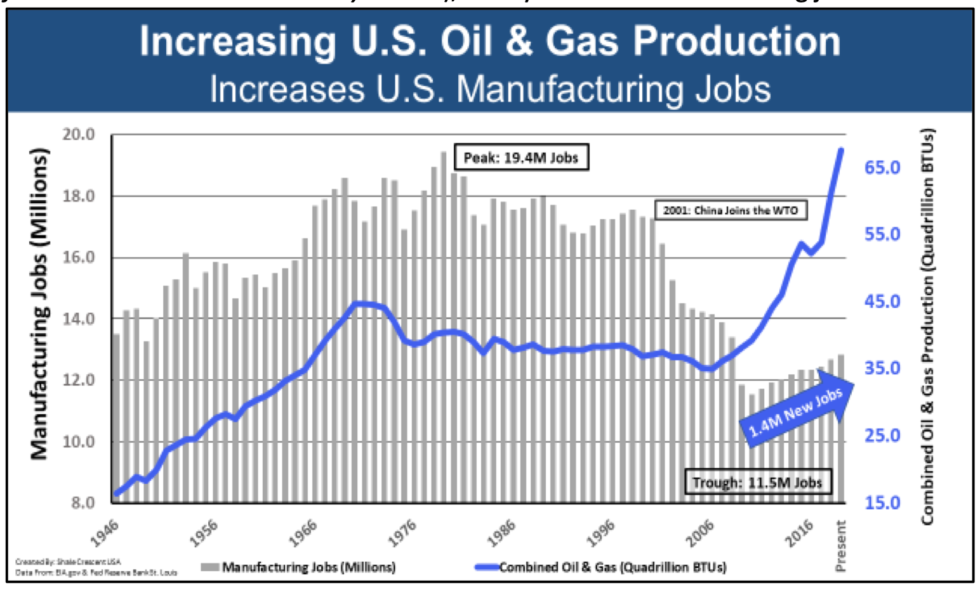
(“U.S. Energy: The Key to the Reviving of U.S. Manufacturing,” ShaleCrescent USA, 10/20; Federal Reserve Bank of St. Louis, Updated 12/8/20)
According to the National Association of Manufacturers, “for every one worker in manufacturing, there are another five employees hired elsewhere.” “For every $1.00 spent in manufacturing, another $2.74 is added to the economy. That is the highest multiplier effect of any economic sector. In addition, for every one worker in manufacturing, there are another five employees hired elsewhere. (Source: NAM calculations using 2018 IMPLAN data.) With that said, recent research suggests that manufacturing’s impacts on the economy are even larger than that if we consider the entire manufacturing value chain plus manufacturing for other industries’ supply chains. That approach estimates that manufacturing could account for one-third of GDP and employment. Along those lines, it also estimated the total multiplier effect for manufacturing to be $3.60 for every $1.00 of value-added output, with one manufacturing employee generating another 3.4 workers elsewhere.” (“Facts About Manufacturing,” National Association of Manufacturers, Accessed 1/29/21)
A 2016 Study By The National Association Of Manufacturers (NAM) Found “The Combination Of Increased Access To Shale Gas And The Transmission Lines That Move That Affordable Energy To Manufacturers Across America Meant 1.9 Million Jobs In 2015 Alone”
A 2016 study by the National Association of Manufacturers (NAM) found that “Going forward, lower natural gas prices will result in benefits to consumer purchasing power and confidence, higher profits among businesses, and improvements in cost-competitiveness for domestic manufacturers relative to their international competitors.” “The rapid increase in domestic natural gas (NG) production continues to reshape the U.S. economy and redefine America’s competitive advantages within the global economy, especially within the manufacturing sector. In the continuing effort to understand how a resurgent oil and gas industry impacts broad-based manufacturing, IHS examined how the expansion of NG pipeline infrastructure benefits the U.S. manufacturing sector. Beyond exploration and production companies, many firms across a diverse set of industry sectors are beneficiaries of tens of billions of dollars in capital expenditures and operating and maintenance (O&M) expenditures made annually across the hydrocarbon value chain. Going forward, lower natural gas prices will result in benefits to consumer purchasing power and confidence, higher profits among businesses, and improvements in cost-competitiveness for domestic manufacturers relative to their international competitors.” (“Natural Gas Study: Energizing Manufacturing,” National Association of Manufacturers, 5/16)
The NAM study estimated that in 2015, “economic benefits from increased domestic shale gas production and the accompanying lower NG prices include contributions of $190 billion to real gross domestic product (GDP), 1.4 million additional jobs, and $156 billion to real disposable income.” “The U.S. economy experienced significant gains in 2015: IHS estimates that economic benefits from increased domestic shale gas production and the accompanying lower NG prices include contributions of $190 billion to real gross domestic product (GDP), 1.4 million additional jobs, and $156 billion to real disposable income.” (“Natural Gas Study: Energizing Manufacturing,” National Association of Manufacturers, 5/16)
In 2015 alone, construction of 6,028 miles of new natural gas transmission pipelines, resulted “in a temporary increase in employment of 347,788 jobs, with 59,874 in the manufacturing sector.” “IHS estimates that approximately $25.8 billion was spent in the U.S. in 2015 to construct 6,028 miles of new natural gas transmission pipelines, resulting in a temporary increase in employment of 347,788 jobs, with 59,874 in the manufacturing sector.” (“Natural Gas Study: Energizing Manufacturing,” National Association of Manufacturers, 5/16)
- NAM Study: “Similarly, the construction spending is expected to have contributed $34 billion to GDP and $21.9 billion to labor income in 2015.” “Similarly, the construction spending is expected to have contributed $34 billion to GDP and $21.9 billion to labor income in 2015. This study presents current unit cost estimates, in dollars per mile, for constructing and operating three types of NG pipelines: gathering, transmission, and local distribution. The focus of this study is on the economic impacts of constructing and operating new NG transmission lines, as they are the means by which pipeline-ready NG is transported from the wellhead to local markets; the effects of the other two other types of NG pipelines will also be considered as appropriate.” (“Natural Gas Study: Energizing Manufacturing,” National Association of Manufacturers, 5/16)
NAM Study: “For energy-intensive industries such as chemicals, metals, food, and refining, production costs have been reduced as a result of the increase in natural gas supply, and IHS expects these industries to outperform the U.S. economy as a whole through 2025.” “Well-understood economic contributions are derived from midstream and downstream energy capital and O&M expenditures across a diverse supply chain. Recent IHS analyses on the U.S. ‘manufacturing renaissance’ identified clear competitive advantages that have emerged for manufacturing in America as a result of the increased supply of competitively priced natural gas. For energy-intensive industries such as chemicals, metals, food, and refining, production costs have been reduced as a result of the increase in natural gas supply, and IHS expects these industries to outperform the U.S. economy as a whole through 2025.” (“Natural Gas Study: Energizing Manufacturing,” National Association of Manufacturers, 5/16)
NAM Study: “Increased supplies of NG, especially at lower delivered prices, enhances the competitiveness of economies by making them more attractive to manufacturing activities that are large, and intensive users of NG such as chemicals, food, paper, and metals.” “The improved competitive positioning of industries in the manufacturing sector is shaping state and local economic development strategies across the country. Increased supplies of NG, especially at lower delivered prices, enhances the competitiveness of economies by making them more attractive to manufacturing activities that are large, and intensive users of NG such as chemicals, food, paper, and metals. The close proximity of existing clusters of manufacturing establishments to increased NG supplies can generate new pipeline-related economic development, often because of the availability of direct connections to a new or expanded NG pipeline.” (“Natural Gas Study: Energizing Manufacturing,” National Association of Manufacturers, 5/16)
NAM Study: “In addition to providing key inputs for the construction of NG pipelines, the manufacturing sector will also benefit economically from the capital expenditures for new electric generating plants and for facilities used to process and store NG and natural gas liquids (NGLs).” “In a recent IHS manufacturing strategy study for the City of Philadelphia Industrial Development Corporation, core recommendations included expansion of NG pipeline capacity from the Marcellus Shale region to the Greater Philadelphia area as an enabler for expanding the regional manufacturing sector. Recent IHS research indicates that sectors such as food, cement, wood, paper, chemicals, and primary and fabricated metal products will be the largest beneficiaries of increased supplies and lower NG prices, as they both use it intensively (i.e., consume a high number of British Thermal Units (Btu) per unit of output) and require large amounts of it, especially in chemicals subsectors, where it is used as a feedstock. Expansions of NG pipeline capacity are also needed to enable the construction of new NG-fired electric generating plants. In addition to providing key inputs for the construction of NG pipelines, the manufacturing sector will also benefit economically from the capital expenditures for new electric generating plants and for facilities used to process and store NG and natural gas liquids (NGLs).” (“Natural Gas Study: Energizing Manufacturing,” National Association of Manufacturers, 5/16)
NAM Study: “In a nutshell, the combination of increased access to shale gas and the transmission lines that move that affordable energy to manufacturers across America meant 1.9 million jobs in 2015 alone.” (“Natural Gas Study: Energizing Manufacturing,” National Association of Manufacturers, 5/16)
For Example, The Chemical Manufacturing Industry, The Single Largest Industrial Consumer Of Natural Gas, Has Invested Over $202 Billion In New Plant Capacity, Which Is “Is Predicted To Generate 786,000 Direct And Indirect Jobs By 2025”
According to the American Chemistry Council, “The chemical manufacturing industry, the single largest industrial consumer of natural gas, has invested over $202 billion in new plant capacity, in part because of the industry’s ability to access cheap gas, which has created a competitive advantage for the U.S. manufacturing sector.” “The chemical manufacturing industry, the single largest industrial consumer of natural gas, has invested over $202 billion in new plant capacity, in part because of the industry’s ability to access cheap gas, which has created a competitive advantage for the U.S. manufacturing sector.” (American Gas Association, et al, Letter to Members of the United States House of Representatives Committee on Energy & Commerce Subcommittee on Energy, 2/3/20)
- “This has created $292 billion in new economic output and is predicted to generate 786,000 direct and indirect jobs by 2025.” “This has created $292 billion in new economic output and is predicted to generate 786,000 direct and indirect jobs by 2025, according to the American Chemistry Council.” (American Gas Association, et al, Letter to Members of the United States House of Representatives Committee on Energy & Commerce Subcommittee on Energy, 2/3/20)
Jobs Flow from the oil and gas energy supply chain
The Oil And Gas Energy Supply Chain Employs Over 600,000 Workers In All Fifty States, With Potential Growth To Over 750,000 By 2025
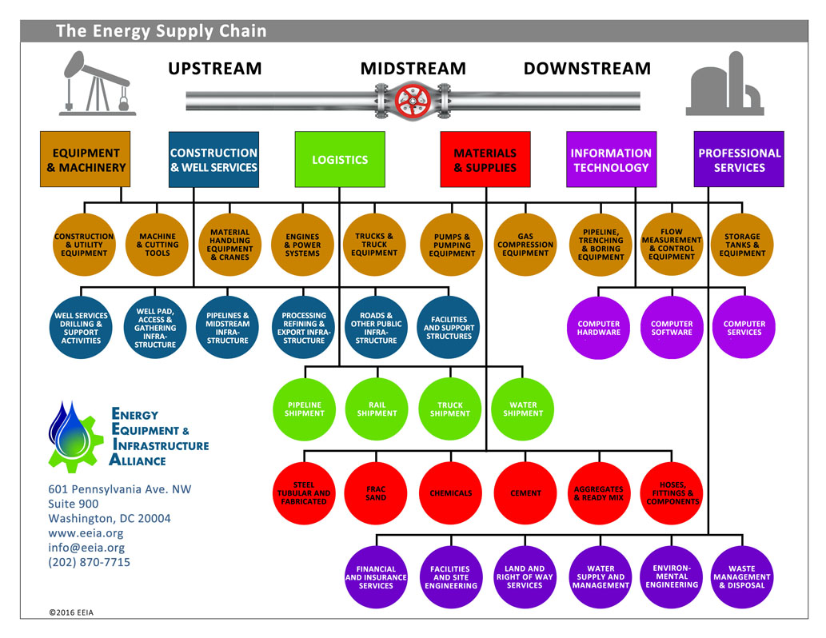
(Energy Equipment & Infrastructure Alliance, 2016)
The oil and gas energy supply chain is made up of “120,000+ companies, of which at least 100,000 are small businesses” … “and workers that produce and supply the equipment, construction, materials, services, logistics and technology used in oil and gas production and operations. “What is the Energy Supply Chain? • Companies and workers that produce and supply the equipment, construction, materials, services, logistics and technology used in oil and gas production and operations • 120,000+ companies, of which at least 100,000 are small businesses • Sixty NAICS‐defined industries” (“FACT SHEET: The Story of the Energy Supply Chain,” Energy Equipment & Infrastructure Alliance, Accessed 9/1/20)
Businesses in the oil and gas energy supply chain include: construction, oilfield services, capital equipment, materials and supplies, professional services, logistics and transportation, and technology. “What types of businesses comprise the Energy Supply Chain? • Construction (well complexes, facilities, roads, pipelines, storage, processing, terminals) • Oilfield Services (drilling, completion, gathering, separation) • Capital Equipment (construction equipment, drilling and completion equipment, tanks, transport, exploration, measurement and control, power generation, pumping) • Materials and Supplies (steel & tubular goods, cement, sand, hoses and fittings) • Professional services (geological, environmental, health and safety, engineering, architecture, financial, legal, scientific) • Logistics (trucking, pipeline operations, water transport, rail) • Technology (seismic imaging, drilling, controls, measurement)” (“FACT SHEET: The Story of the Energy Supply Chain,” Energy Equipment & Infrastructure Alliance, Accessed 9/1/20)
Trades and professions that work in the oil and gas energy supply chain include: factory and warehouse; construction; equipment operators, truck drivers and mechanics; welders and ironworkers; technicians, maintenance and administrative workers; and professionals fields like engineers, scientific, architects, and financial. “What types of trades and professions work in the energy supply chain? • Factory and warehouse workers • Construction workers • Equipment operators, truck drivers and mechanics • Welders and ironworkers • Technicians, maintenance and administrative workers • Professionals: engineers, scientific, architects, financial.” (“FACT SHEET: The Story of the Energy Supply Chain,” Energy Equipment & Infrastructure Alliance, Accessed 9/1/20)
The oil and gas energy supply chain provides over $150 billion of economic output with potential growth to over $200 billion by 2025. “What is the economic impact of the Energy Supply Chain? • Over $150 billion of economic output • Growth to over $200 billion by 2025” (“FACT SHEET: The Story of the Energy Supply Chain,” Energy Equipment & Infrastructure Alliance, Accessed 9/1/20)
The oil and gas energy supply chain employs over 600,000 workers with potential growth to over 750,000 by 2025. “What are the employment dimensions of the Energy Supply Chain? • 600,000+ workers; growing to over 750,000 by 2025 • Well‐paying jobs; income (annual average) of $79,000 per job • Three workers in the supply chain for each one at the producing level • Six more in the induced economy (retail, hospitality, housing, services, etc.)” (“FACT SHEET: The Story of the Energy Supply Chain,” Energy Equipment & Infrastructure Alliance, Accessed 9/1/20)
“Shale energy supply chain jobs account for 2% of total state employment in Texas, Louisiana, and Oklahoma. Supply chain employment accounts for 1% of total state employment in Arkansas, Colorado, and Pennsylvania.” (“Facts You Should Know About Shale Energy,” Energy Equipment & Infrastructure Alliance, Accessed 9/1/20; "Supplying the Unconventional Revolution,” IHS Economics, 2014)
Workers in the oil and gas energy supply chain earn an average annual income of $79,000. “What are the employment dimensions of the Energy Supply Chain? • 600,000+ workers; growing to over 750,000 by 2025 • Well‐paying jobs; income (annual average) of $79,000 per job • Three workers in the supply chain for each one at the producing level • Six more in the induced economy (retail, hospitality, housing, services, etc.)” (“FACT SHEET: The Story of the Energy Supply Chain,” Energy Equipment & Infrastructure Alliance, Accessed 9/1/20)
“Shale energy supply chain workers' total incomes will grow from an total of $41 billion in 2012 to close to $60 billion in 2025.” (“Facts You Should Know About Shale Energy,” Energy Equipment & Infrastructure Alliance, Accessed 9/1/20; "Supplying the Unconventional Revolution,” IHS Economics, 2014)
For each one worker at the oil and gas production level there are three workers in the energy supply chain and six more in the induced economy like retail, hospitality, housing, and other services. “What are the employment dimensions of the Energy Supply Chain? • 600,000+ workers; growing to over 750,000 by 2025 • Well‐paying jobs; income (annual average) of $79,000 per job • Three workers in the supply chain for each one at the producing level • Six more in the induced economy (retail, hospitality, housing, services, etc.)” (“FACT SHEET: The Story of the Energy Supply Chain,” Energy Equipment & Infrastructure Alliance, Accessed 9/1/20)
Oil and gas energy supply chain businesses and jobs are in all fifty states. “What is the geographic scope of the Energy Supply Chain? • Supply chain businesses and jobs are in all fifty states • Non‐producing states are big winners. With production growth, ten of the top fifteen job‐gaining states are non‐producing. Example: Illinois, New York and Florida rank 3rd 4th and 5th after Texas and California • The energy midstream crisscrosses all of America: pipelines, rail, water, trucks” (“FACT SHEET: The Story of the Energy Supply Chain,” Energy Equipment & Infrastructure Alliance, Accessed 9/1/20)
Oil and gas jobs provide more advantages for workers Than Renewables
A July 2020 Study By North America's Building Trades Unions, Found That Oil And Gas Jobs “Have Better Wages, Benefits And Opportunities Than Renewables Projects”
A July 2020 survey of “both union and non-union” tradespeople reported that oil and gas jobs “have better wages, benefits and opportunities than renewables projects.” “In July the NABTU—whose affiliates include the Teamsters and International Brotherhood of Electrical Workers—released two surveys of workers and statistics that analyze jobs across the energy economy. They found that ‘both union and non-union’ tradespeople report that oil and gas jobs ‘have better wages, benefits and opportunities than renewables projects.’” (Editorial, “About Joe’s Energy Jobs,” The Wall Street Journal, 8/24/20)
“Workers reported that oil and gas jobs were longer-term, resulting in steadier incomes and more consistent benefits.” “One survey conducted interviews, focus groups and an online survey with some 1,700 union and non-union workers in energy jobs. Workers reported that oil and gas jobs were longer-term, resulting in steadier incomes and more consistent benefits.” (Editorial, “About Joe’s Energy Jobs,” The Wall Street Journal, 8/24/20)
- “‘With solar, you work your way out of a job. … Three months duration [then] you’re done,’ explained one electrician.” (Editorial, “About Joe’s Energy Jobs,” The Wall Street Journal, 8/24/20)
“Workers also liked that there was ‘better project variety, skill development and project consistency.’” (Editorial, “About Joe’s Energy Jobs,” The Wall Street Journal, 8/24/20)
“The report emphasized that ‘skilled trade jobs are not highly interchangeable between industries.’” (Editorial, “About Joe’s Energy Jobs,” The Wall Street Journal, 8/24/20)
The Oil And Gas Industry Provides An Average Annual Salary Of $108,000, “Nearly Twice The Private Economy Average” And NABTU estimates That Many Members Would “Take A 50% Or 75% Pay Cut” If They Changed Jobs Into The Renewable Energy Industry
According to the Bureau of Labor Statistics the oil and gas industry provides an average annual salary of $108,000, “nearly twice the private economy average” and can be even higher at large companies like Exxon Mobil, where median worker pay is about $170,000 a year. “The Bureau of Labor Statistics says the oil and gas industry provides an average annual salary of $108,000, nearly twice the private economy average. A Journal analysis last year found even higher average wages at large companies like Exxon Mobil, where median worker pay is about $170,000 a year.” (Editorial, “About Joe’s Energy Jobs,” The Wall Street Journal, 8/24/20)
North America's Building Trades Unions (NABTU) president Sean McGarvey estimates that many union members would “take a 50% or 75% pay cut” if they changed jobs into the renewable energy industry. “Renewable medians are harder to measure, but NABTU president Sean McGarvey estimates that many union members would ‘take a 50% or 75% pay cut.’ In 2008 Barack Obama promised millions of ‘green jobs,’ but the great irony was that the oil-and-gas fracking revolution provided the real employment boom of his Presidency. According to a Bloomberg News analysis, the U.S. fossil fuels industry employs nearly five million people, including 250,000 in Pennsylvania, 174,000 in Ohio and 839,000 in Texas. Now Mr. Biden wants to extinguish those jobs on a bet on solar panels and wind turbines. As the union workers put it, c’mon, man.” (Editorial, “About Joe’s Energy Jobs,” The Wall Street Journal, 8/24/20)
“‘The findings outlined in these reports demonstrate that today’s oil and natural gas jobs are better for energy construction workers across the country in both the short and long term,’ said Sean McGarvey, President of North America’s Building Trades Unions.” (“NABTU Issues Two New Studies Showing The Great Opportunities In And Job Quality Importance Of Energy Construction,” North America's Building Trades Unions, 7/17/20)
- McGarvey: “The research confirms what our members tell us: the career opportunities for renewables are nowhere near what they are in gas and oil, and domestic energy workers highly value the safety, reliable duration and compensation of oil and gas construction jobs.” (“NABTU Issues Two New Studies Showing The Great Opportunities In And Job Quality Importance Of Energy Construction,” North America's Building Trades Unions, 7/17/20)
In July 2020, North America's Building Trades Unions (NABTU) “commissioned two research studies – one quantitative and one qualitative – to better understand the important role that trades jobs play in the US economy, and the differences in those jobs across various energy sectors.” “NABTU has recently commissioned two research studies – one quantitative and one qualitative – to better understand the important role that trades jobs play in the US economy, and the differences in those jobs across various energy sectors.” (“Construction Job Quality Across the US Energy Industries,” North America's Building Trades Unions, 7/17/20)
The NABTU studies interviewed and surveyed individuals working in “varying geographies, energy industries, and construction trades.” “The first study is a comprehensive, qualitative analysis by the Cicero Group, Perspectives and Comparisons of Job Quality Across the US Energy Industries. The Cicero Group Study was conducted, including research and analysis, from October 2019 –February 2020 and included both secondary and primary data sources. Secondary sources in the Cicero study included government data from sources including the Bureau of Labor Statistics (BLS), the U.S. Energy Information Administration (EIA), and the United States Environmental Protection Agency (US EPA); 22 in-depth interviews with individuals from varying geographies and energy industries; 8 focus groups with individuals from varying geographies, energy industries, and trades; and an online survey with over 1,600 respondents from varying geographies, energy industries, and construction trades.” (“Construction Job Quality Across the US Energy Industries,” North America's Building Trades Unions, 7/17/20)
The NABTU studies found that, “Energy sector jobs and energy sector construction jobs provide Americans without a college education a vital pathway to middle class careers and living standards.” (“Construction Job Quality Across the US Energy Industries,” North America's Building Trades Unions, 7/17/20)
NABTU Studies: “Tradespeople working in energy construction report that they consider projects in oil and natural gas industries to have better wages, benefits, and opportunities than renewables projects.” (“Construction Job Quality Across the US Energy Industries,” North America's Building Trades Unions, 7/17/20)
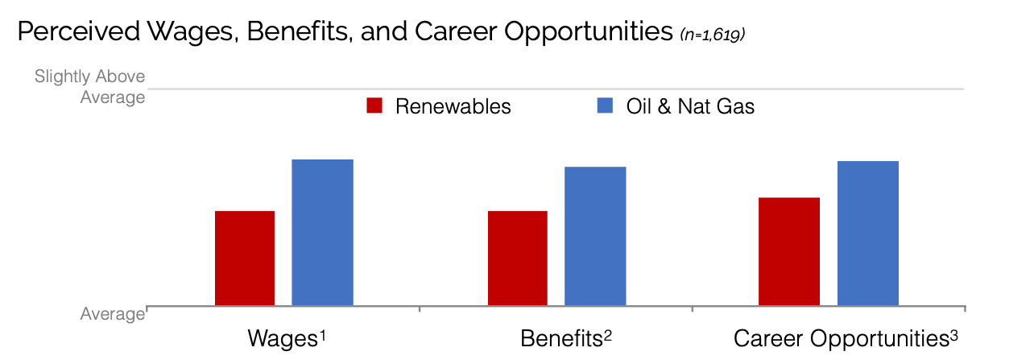
(“Construction Job Quality Across the US Energy Industries,” North America's Building Trades Unions, 7/17/20)
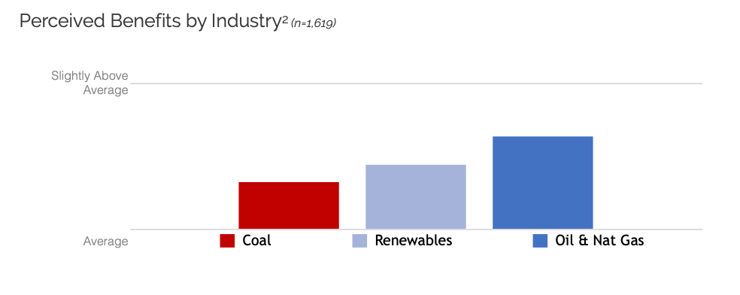
(“Construction Job Quality Across the US Energy Industries,” North America's Building Trades Unions, 7/17/20)
(“Construction Job Quality Across the US Energy Industries,” North America's Building Trades Unions, 7/17/20)
NABTU Studies: “Tradespeople also report that the oil and natural gas industries offer projects with longer durations than those in renewables industries, which means steadier income and more consistent benefits.” (“Construction Job Quality Across the US Energy Industries,” North America's Building Trades Unions, 7/17/20)
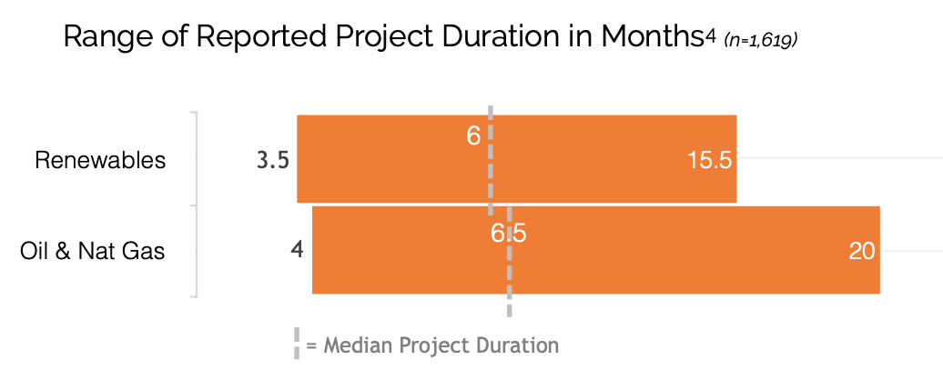
(“Construction Job Quality Across the US Energy Industries,” North America's Building Trades Unions, 7/17/20)
NABTU Studies: “Many of the trades that work on oil and natural gas projects are not as prevalent on renewables projects, indicating that skilled trade jobs are not highly interchangeable between industries.” “Tradespeople report noteworthy differences between projects in renewable energy and oil and natural gas projects. They report better project variety, trades opportunities, skill development, and project consistency in oil and natural gas construction. Many of the trades that work on oil and natural gas projects are not as prevalent on renewables projects, indicating that skilled trade jobs are not highly interchangeable between industries.” (“Construction Job Quality Across the US Energy Industries,” North America's Building Trades Unions, 7/17/20)
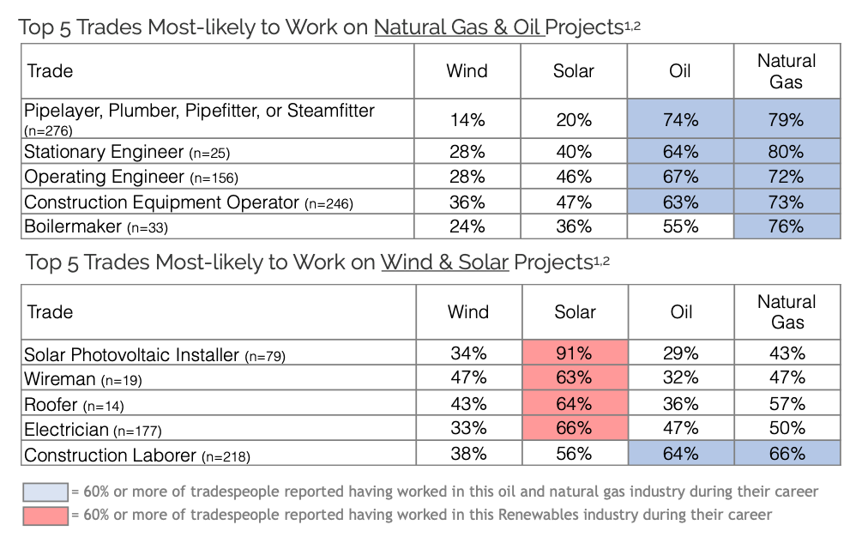
(“Construction Job Quality Across the US Energy Industries,” North America's Building Trades Unions, 7/17/20)
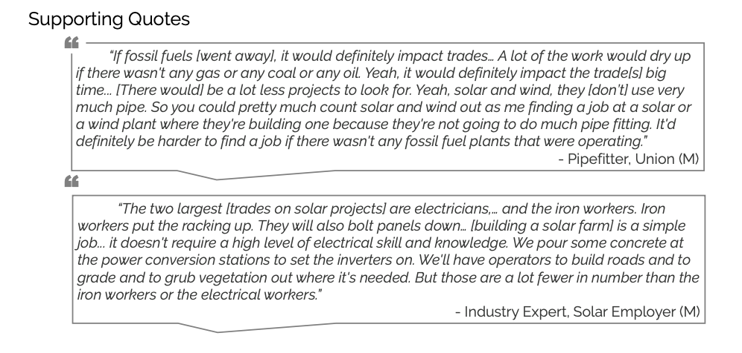
(“Construction Job Quality Across the US Energy Industries,” North America's Building Trades Unions, 7/17/20)
NABTU Studies: “The oil and natural gas industry’s reliance on registered apprenticeship and strict industry safety standards and procedures make workers safer in this segment of the construction industry.” “When it comes to safety, tradespeople perceive that renewables projects are slightly safer than oil and natural gas projects, but oil and natural gas projects are not considered ‘unsafe’ by the average tradesperson. The oil and natural gas industry’s reliance on registered apprenticeship and strict industry safety standards and procedures make workers safer in this segment of the construction industry.” (“Construction Job Quality Across the US Energy Industries,” North America's Building Trades Unions, 7/17/20)
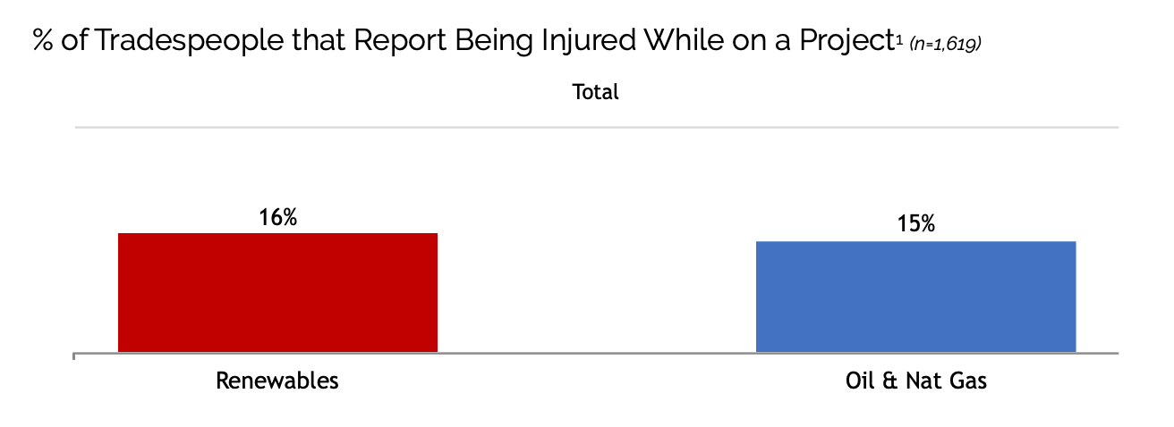
(“Construction Job Quality Across the US Energy Industries,” North America's Building Trades Unions, 7/17/20)
NABTU Studies: “A mature industry infrastructure such as that in oil and gas is likely to allow more skilled tradespeople the opportunity to work in the energy sector while remaining closer to their homes and families.” “Most tradespeople are constrained to projects within a reasonable driving distance from their homes and families. Tradespeople in every industry report commuting about an hour to the project site. A mature industry infrastructure such as that in oil and gas is likely to allow more skilled tradespeople the opportunity to work in the energy sector while remaining closer to their homes and families.” (“Construction Job Quality Across the US Energy Industries,” North America's Building Trades Unions, 7/17/20)
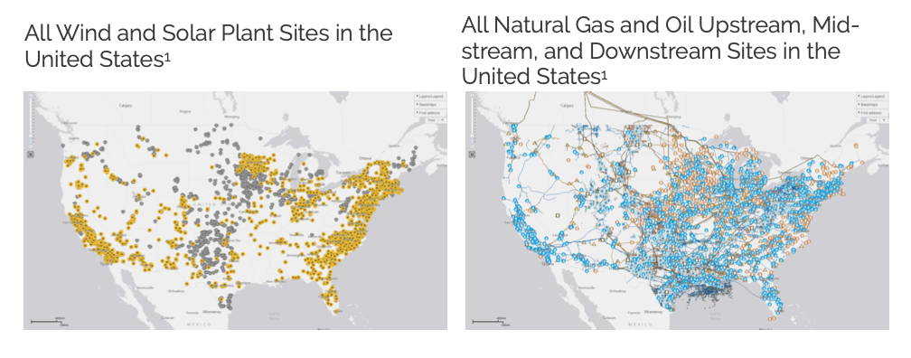
(“Construction Job Quality Across the US Energy Industries,” North America's Building Trades Unions, 7/17/20)
(“Construction Job Quality Across the US Energy Industries,” North America's Building Trades Unions, 7/17/20)
NABTU Studies: “Tradespeople report better project variety, skill development, and project consistency in the oil and natural gas industries compared to the work being done in the wind and solar industries. Better consistency is often attributed to regular maintenance and upgrades.” (“Construction Job Quality Across the US Energy Industries,” North America's Building Trades Unions, 7/17/20)

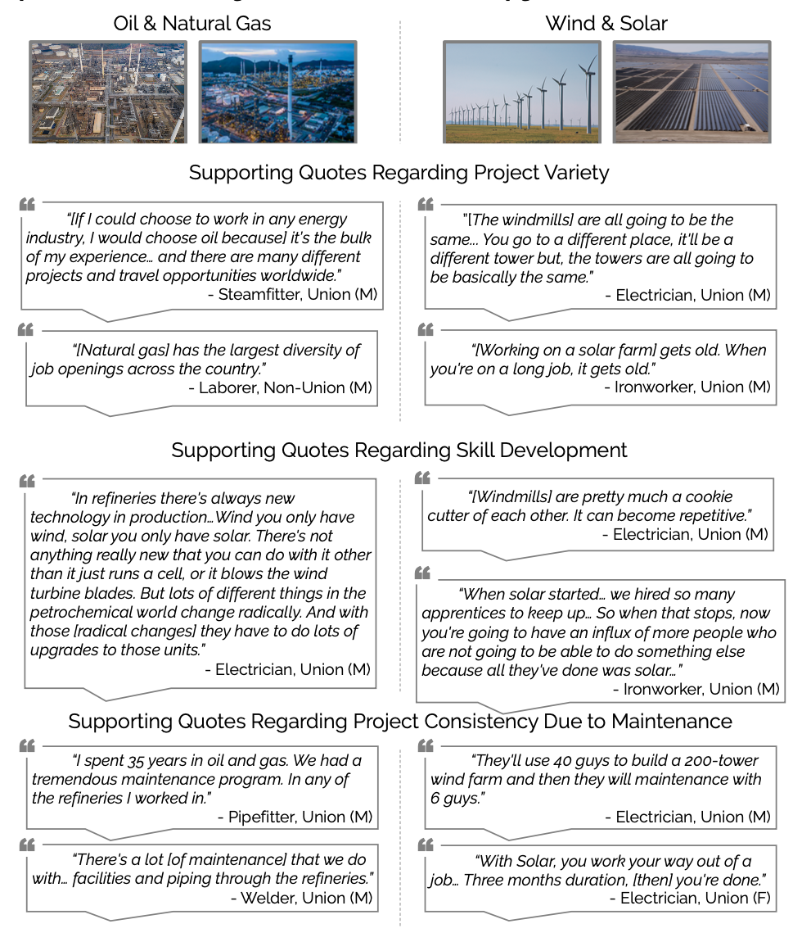
(“Construction Job Quality Across the US Energy Industries,” North America's Building Trades Unions, 7/17/20)
NABTU Studies: “The construction and oil & natural gas industries rely heavily on high school graduates to staff about 45 percent of all the jobs in these two industries. Relative to many other high school graduates with no college education, high school graduates in construction, oil & natural gas are paid better while receiving more health insurance and pension coverage.” “In some industries, the road to a productive and rewarding career need not go through college. Thirty percent of all employees and 25 percent of the workers 25 years and older in the US labor market are high school graduates with no college education. The construction and oil & natural gas industries rely heavily on high school graduates to staff about 45 percent of all the jobs in these two industries. Relative to many other high school graduates with no college education, high school graduates in construction, oil & natural gas are paid better while receiving more health insurance and pension coverage. This is both true for blue-collar and white-collar high school graduates in these two industries. It is especially true of union workers in construction and oil & natural gas.” (“Construction Job Quality Across the US Energy Industries,” North America's Building Trades Unions, 7/17/20)

