Biden Promises To “Revitalize” American Manufacturing, But The Declines He Wants In Domestic Oil And Gas Production Historically Kill Manufacturing Jobs
Despite several moves to diminish U.S. oil and natural gas production, Biden claims that his plan will “revitalize” American manufacturing. “Revitalize manufacturing, secure U.S. supply chains, invest in R&D, and train Americans for the jobs of the future. President Biden’s plan will ensure that the best, diverse minds in America are put to work creating the innovations of the future while creating hundreds of thousands of quality jobs today. Our workers will build and make things in every part of America, and they will be trained for well-paying, middle-class jobs.” (“FACT SHEET: The American Jobs Plan,” The White House, 3/31/21)
From the mid 1970s to the early 2000s, U.S. oil and gas production declined and nearly three million manufacturing jobs were lost. And, another five million manufacturing jobs were lost when China joined the World Trade Organization in 2001. “The following chart illustrates the direct correlation of U.S. Oil and Gas Production to U.S. Manufacturing jobs. As oil and gas production rose, so did the ability to competitively manufacture within the United States. Similarly, as U.S. Oil and Gas production declined (seen from the mid 1970’s to the early 2000’s), nearly 3 million manufacturing jobs were lost. Another 5 million manufacturing jobs were lost when China joined the WTO in 2001. However, the amount of total jobs lost is actually much larger. For every one manufacturing job created, there are four to five supporting jobs generated.” (“U.S. Energy: The Key to the Reviving of U.S. Manufacturing,” ShaleCrescent USA, 10/20; Federal Reserve Bank of St. Louis, Updated 12/8/20)
In contrast, increases in U.S. oil and gas production help to fuel growth in U.S. manufacturing jobs. Over the last decade, the surge in production from the shale revolution has helped create 1.4 million new manufacturing jobs for Americans. “Around 2010, due to shale development, U.S. oil and gas production reversed course and the U.S. quickly became the number one oil gas producing country in the world. As a result, manufacturing jobs began to rebound. Today, there have been 1.4 million manufacturing jobs created since the U.S. shale development.” (“U.S. Energy: The Key to the Reviving of U.S. Manufacturing,” ShaleCrescent USA, 10/20; Federal Reserve Bank of St. Louis, Updated 12/8/20)
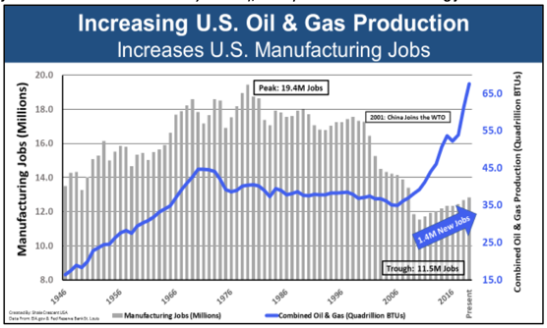
(“U.S. Energy: The Key to the Reviving of U.S. Manufacturing,” ShaleCrescent USA, 10/20; Federal Reserve Bank of St. Louis, Updated 12/8/20)
Biden Pushes A “Made In America” Agenda, But His Push Toward “Green” Energy And Electric Vehicles Would Make Us Dependent On China For Resources
Biden wants to transition the country to a “carbon-free” electrical grid based on wind and solar power by 2035, but claims his plan will “require that goods and materials are made in America and shipped on U.S.-flag, U.S.-crewed vessels” so that “American taxpayers’ dollars benefit working families and their communities, and not multinational corporations or foreign governments.” “Create good-quality jobs that pay prevailing wages in safe and healthy workplaces while ensuring workers have a free and fair choice to organize, join a union, and bargain collectively with their employers. By ensuring that American taxpayers’ dollars benefit working families and their communities, and not multinational corporations or foreign governments, the plan will require that goods and materials are made in America and shipped on U.S.-flag, U.S.-crewed vessels. The plan also will ensure that Americans who have endured systemic discrimination and exclusion for generations finally have a fair shot at obtaining good paying jobs and being part of a union.” (“FACT SHEET: The American Jobs Plan,” The White House, 3/31/21)
Rare earth metals are ingredients integral to building batteries and other technologies for electric vehicles and renewable energy sources like, wind and solar power. (James MacDonald, “The Downside To Renewable Energy, JSTOR Daily, 5/6/19; “U.S. Dependence On China's Rare Earth: Trade War Vulnerability,” Reuters, 6/27/19)
China has a near monopoly, at least 85% of the world’s capacity, to process rare earth ores into material manufacturers can use. “China is home to at least 85% of the world’s capacity to process rare earth ores into material manufacturers can use, according to research firm Adamas Intelligence.” (“U.S. Dependence On China's Rare Earth: Trade War Vulnerability,” Reuters, 6/27/19)
For example, China supplies 80 percent of the world’s polysilicon, and Xinjiang, a Chinese region known for human rights abuses, produces half the world’s supply. In contrast, the U.S. produces less than 5% of the mineral. “China supplies more than 80% of polysilicon, and Xinjiang alone provides nearly half of global production, said BloombergNEF solar analyst Xiaoting Wang. By contrast, the U.S. now produces less than 5% of the world’s solar-grade polysilicon – with almost all of it coming from a single plant in Michigan, according to BloombergNEF’s Yali Jiang.” (Jenny Leonard and Jennifer A. Dlouhy, “Biden’s Solar Dreams Collide With Outrage Over China’s ‘Genocide’,” Bloomberg Green, 3/16/21)
Biden Wants To Spend $174 Billion On Tax “Incentives” To Increase Electric Vehicles, But Most Credits Benefit Corporations And High-Income Individuals
Biden plans to spend $174 billion to increase electric vehicles in the U.S. by giving “consumers point of sale rebates and tax incentives to buy American-made EVs” and through “incentive programs for state and local governments and the private sector.” “U.S. market share of plug-in electric vehicle (EV) sales is only one-third the size of the Chinese EV market. The President believes that must change. He is proposing a $174 billion investment to win the EV market. His plan will enable automakers to spur domestic supply chains from raw materials to parts, retool factories to compete globally, and support American workers to make batteries and EVs. It will give consumers point of sale rebates and tax incentives to buy American-made EVs, while ensuring that these vehicles are affordable for all families and manufactured by workers with good jobs. It will establish grant and incentive programs for state and local governments and the private sector to build a national network of 500,000 EV chargers by 2030, while promoting strong labor, training, and installation standards.” (“FACT SHEET: The American Jobs Plan,” The White House, 3/31/21)
- For comparison, that’s about $60 billion more than what Biden’s “infrastructure” plan invests in repairing roads and bridges. “The President is proposing a total increase of $115 billion to modernize the bridges, highways, roads, and main streets that are in most critical need of repair. This includes funding to improve air quality, limit greenhouse gas emissions, and reduce congestion.” (“FACT SHEET: The American Jobs Plan,” The White House, 3/31/21)
According to a congressional report, the vast majority of electrical vehicle tax incentives go to corporations and high-income individuals. “According to Joint Committee on Taxation (JCT) estimates, between FY2018 and FY2022, about half of the forgone revenue associated with the plug-in EV tax credit will be for corporations claiming the credit (Figure 1). This could be businesses purchasing EVs. This also could be instances where sellers are claiming the credit for vehicles sold or leased to tax-exempt entities. In 2016, 57,066 individual taxpayers claimed $375 million in plug-in EV tax credits. EV tax credits are disproportionately claimed by higher-income taxpayers. Most of the tax credits (78%) are claimed by filers with adjusted gross income (AGI) of $100,000 or more, and those filers receive an even higher proportion (83%) of the amount of credits claimed. About 7% of credits claimed, and 8% of the total amount of credits, were on returns where the taxpayer’s AGI exceeded $1 million. Across all taxpayers, about 17% of returns filed have an AGI of $100,000 or more. About 0.3% have an AGI of $1 million or more.” (“The Plug-In Electric Vehicle Tax Credit,” Congressional Research Service, 5/14/19)
Biden Wants To Spend $10 Billion On A “Civilian Climate Corps” With A Sweeping, Vague Mission
Light on details, Biden intends to spend $10 billion on a “Civilian Climate Corps” to “put a new, diverse generation of Americans to work conserving our public lands and waters, bolstering community resilience, and advancing environmental justice.” “This $10 billion investment will put a new, diverse generation of Americans to work conserving our public lands and waters, bolstering community resilience, and advancing environmental justice through a new Civilian Climate Corps, all while placing good-paying union jobs within reach for more Americans.” (“FACT SHEET: The American Jobs Plan,” The White House, 3/31/21)
Biden Calls For Affordable “Electrified” Housing And Schools, Which Which Will Likely Have Unaffordable Energy Bills
Biden calls for $213 billion in spending to build and upgrade “more than two million affordable and sustainable places to live,” including “more than a million affordable, resilient, accessible, energy efficient, and electrified housing units.” “The President’s plan invests $213 billion to produce, preserve, and retrofit more than two million affordable and sustainable places to live. … President Biden is calling on Congress to: Produce, preserve, and retrofit more than a million affordable, resilient, accessible, energy efficient, and electrified housing units. Through targeted tax credits, formula funding, grants, and project-based rental assistance, President Biden’s plan will extend affordable housing rental opportunities to underserved communities nationwide, including rural and tribal areas.” (“FACT SHEET: The American Jobs Plan,” The White House, 3/31/21)
Biden calls for $100 billion in spending to build and upgrade public schools that “will invest in cutting-edge, energy-efficient and electrified, resilient, and innovative school buildings.” “The President’s plan invests $100 billion to upgrade and build new public schools, through $50 billion in direct grants and an additional $50 billion leveraged through bonds. These funds will first go toward making sure our schools are safe and healthy places of learning for our kids and work for teachers and other education professionals, for example by improving indoor air quality and ventilation. As we make our schools safer, we also will invest in cutting-edge, energy-efficient and electrified, resilient, and innovative school buildings with technology and labs that will help our educators prepare students to be productive workers and valued students. Under the President’s plan, better operating school facilities will reduce their greenhouse gas emissions and also will become environments of community resilience with green space, clean air, and safe places to gather, especially during emergencies.” (“FACT SHEET: The American Jobs Plan,” The White House, 3/31/21)
Households that use natural gas for heating, cooking and other appliances save an average $879 per year compared to homes using electricity for such appliances. (“Natural Gas Act Offers Clear Pathway to American Energy Abundance,” American Gas Association, 2/5/20)
A 2019 report from the Council of Economic Advisers found that price decreases that resulted from the American shale revolution have saved an average family of four $2,500 a year—that’s a $203 billion annual savings for U.S. consumers. (“The Value of U.S. Energy Innovation and Policies Supporting the Shale Revolution,” The Council of Economic Advisers, 10/19)
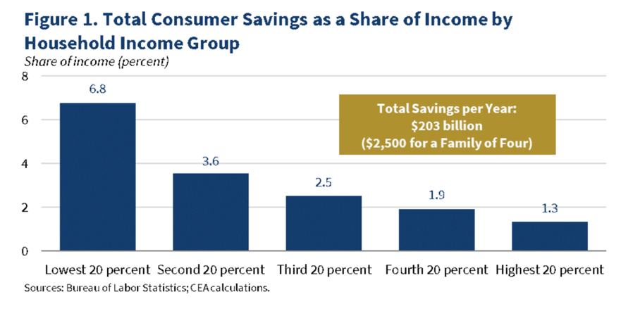
(“The Value of U.S. Energy Innovation and Policies Supporting the Shale Revolution,” The Council of Economic Advisers, 10/19)
Biden Wants To Finance His “Carbon-Pollution Free” Electrical Grid With Tax Subsidy Handouts…But, For Everyone Else, A Tax Hike
Biden once again calls for “100 percent carbon-pollution free power by 2035.” “All of this will be done while ensuring those facilities meet robust and rigorous standards for worker, public, and environmental safety as well as environmental justice – and all while moving toward 100 percent carbon-pollution free power by 2035.” (“FACT SHEET: The American Jobs Plan,” The White House, 3/31/21)
To get there, Biden calls for “a targeted investment tax credit that incentivizes the buildout of at least 20 gigawatts of high-voltage capacity power lines and mobilizes tens of billions in private capital off the sidelines – right away.” “Build a more resilient electric transmission system. Through investments in the grid, we can move cheaper, cleaner electricity to where it is needed most. This starts with the creation of a targeted investment tax credit that incentivizes the buildout of at least 20 gigawatts of high-voltage capacity power lines and mobilizes tens of billions in private capital off the sidelines – right away.” (“FACT SHEET: The American Jobs Plan,” The White House, 3/31/21)
And, “President Biden is proposing a ten-year extension and phase down of an expanded direct-pay investment tax credit and production tax credit for clean energy generation and storage.” (“FACT SHEET: The American Jobs Plan,” The White House, 3/31/21)
Biden ends his “American Jobs Plan” with “The Made In America Tax Plan” that will “raise over $2 trillion over the next 15 years” “President Biden’s reform will also make the United States a leader again in the world and help bring an end to the race-to-the-bottom on corporate tax rates that allows countries to gain a competitive advantage by becoming tax havens. This is a generational opportunity to fundamentally shift how countries around the world tax corporations so that big corporations can’t escape or eliminate the taxes they owe by offshoring jobs and profits from the United States. Together these corporate tax changes will raise over $2 trillion over the next 15 years and more than pay for the mostly one-time investments in the American Jobs Plan and then reduce deficits on a permanent basis.” (“FACT SHEET: The American Jobs Plan,” The White House, 3/31/21)

