

***Travel***

**According to AAA, in 2021, nearly 48 million Americans plan to travel for the Fourth of July.** “More than 47.7 million Americans will take to the nation’s roadways and skies this Independence Day (July 1–5), as travel volumes are expected to nearly fully recover to pre-pandemic levels. In fact, this will be the second-highest Independence Day travel volume on record, trailing only 2019. Overall, just 2.5% fewer Americans are expected to travel this year compared to Independence Day in 2019. This represents an increase of nearly 40% compared to last year, when total travel fell to 34.2 million.” (“AAA: More Than 47M Americans to Celebrate With an Independence Day Getaway,” [AAA Newsroom](https://newsroom.aaa.com/2021/06/aaa-more-than-47m-americans-to-celebrate-with-an-independence-day-getaway/), 6/22/21)

* **43.6 million Americans—91 percent of those planning to travel for July 4—will travel by car.** “While all modes of travel will see increased demand this Independence Day, road trips continue to dominate this summer. Despite the highest gas prices in seven years, more than 91% of holiday travel will be by car. An expected 43.6 million Americans will drive to their destinations, the highest on record for this holiday and 5% more than the previous record set in 2019.” (“AAA: More Than 47M Americans to Celebrate With an Independence Day Getaway,” [AAA Newsroom](https://newsroom.aaa.com/2021/06/aaa-more-than-47m-americans-to-celebrate-with-an-independence-day-getaway/), 6/22/21)
* **3.5 million Americans are planning to fly for the July 4 holiday.** “With 3.5 million people planning to fly, air travel volumes this Independence Day will reach 90% of pre-pandemic levels, and increase 164% compared to last year.” (“AAA: More Than 47M Americans to Celebrate With an Independence Day Getaway,” [AAA Newsroom](https://newsroom.aaa.com/2021/06/aaa-more-than-47m-americans-to-celebrate-with-an-independence-day-getaway/), 6/22/21)
* **620,000 Americans plan to travel by train, bus or cruise ship for the holiday.** “Another 620,000 Americans are expected to travel by other modes this Independence Day, an increase of over 72% compared to last year, but 83% lower than in 2019. This includes travel by bus and train, and also the return of cruising. Cruise lines have announced limited sailings resuming from U.S. ports beginning in late June.” (“AAA: More Than 47M Americans to Celebrate With an Independence Day Getaway,” [AAA Newsroom](https://newsroom.aaa.com/2021/06/aaa-more-than-47m-americans-to-celebrate-with-an-independence-day-getaway/), 6/22/21)

**According to AAA, in 2019, nearly 49 million Americans planned to travel for the Fourth of July.** “More Americans than ever recorded by AAA, nearly 49 million, are making plans to honor the red, white and blue with an Independence Day getaway this year. (AAA began tracking holiday travel in 2000.) Overall travel volume for the holiday is expected to rise 4.1% over last year, with an additional 1.9 million people planning road trips and other vacations to celebrate America’s birthday. For the record-high 41.4 million Americans who will travel by automobile this Independence Day, INRIX, a global mobility analytics company, predicts drivers could face delays as much as four times a normal commute, with Wednesday, July 3 the worst day on the roads.” (“Record-Breaking 48.9 Million Americans to Travel this Independence Day,” [AAA Newsroom](https://newsroom.aaa.com/2019/06/record-breaking-48-9-million-americans-travel-fourth-of-july/), 6/25/19)

* **The vast majority of those American travelers—41.4 million—planned to drive on road trips for the holiday.** “Automobiles: The vast majority of travelers – 41.4 million – will hit the road, the most on record for the holiday and 4.3% more than last year.” (“Record-Breaking 48.9 Million Americans to Travel this Independence Day,” [AAA Newsroom](https://newsroom.aaa.com/2019/06/record-breaking-48-9-million-americans-travel-fourth-of-july/), 6/25/19)
* **3.96 million Americans planned to fly for the holiday.** “Planes: 3.96 million people will take to the skies, the highest number on record and 5.3% more than last year.” (“Record-Breaking 48.9 Million Americans to Travel this Independence Day,” [AAA Newsroom](https://newsroom.aaa.com/2019/06/record-breaking-48-9-million-americans-travel-fourth-of-july/), 6/25/19)
* **3.55 million other Americans planned to travel by train, bus or cruise ship for the holiday.** “Trains, Buses and Cruise Ships: Travel across these sectors will increase by 0.6% to 3.55 million passengers.” (“Record-Breaking 48.9 Million Americans to Travel this Independence Day,” [AAA Newsroom](https://newsroom.aaa.com/2019/06/record-breaking-48-9-million-americans-travel-fourth-of-july/), 6/25/19)

**According to spending trends collected by Bank of America, “In 2018, July 2 was the summer day when Americans spent the most on travel -- 27% more than the average day.”** “In fact, in 2018, July 2 was the summer day when Americans spent the most on travel -- 27% more than the average day.” (Daniel B. Kline, “Here's What Americans Are Spending for the 4th of July,” [The Motley Fool](https://www.fool.com/investing/2019/06/28/heres-what-americans-are-spending-for-the-4th-of-j.aspx), 6/28/19)

**On Friday, June 30, 2018, preceding the holiday weekend, gas spending was 32% above average—the second highest gas spending day of the summer.** “Gas sales actually dropped by 15% on the holiday itself compared to an average day. That's likely because most people gassed up on Friday, June 30, a day where gas spending was 32% above average (the second highest gas spending day of the summer).” (Daniel B. Kline, “Here's What Americans Are Spending for the 4th of July,” [The Motley Fool](https://www.fool.com/investing/2019/06/28/heres-what-americans-are-spending-for-the-4th-of-j.aspx), 6/28/19)

**According to GasBuddy, “57 percent of Americans plan to take at least one road trip this summer.”** “We are conflicted about summer travel in 2021. With more people vaccinated and the economy opening, 57 percent of Americans plan to take at least one road trip this summer, up substantially from 2020’s 31 percent, according to GasBuddy’s annual summer travel survey.” (“Gasbuddy Predicts Most Expensive Summer Gas Prices Since 2014 As More Americans Plan To Hit The Road,” [GasBuddy](https://www.gasbuddy.com/go/gasbuddy-predicts-most-expensive-summer-gas-prices-since-2014-as-more-americans-plan-to-hit-the-road), 5/18/21)

**“Forty-six percent surveyed say that high gas prices are directly impacting their travel plans compared to only 4 percent saying so in 2020.”** (“Gasbuddy Predicts Most Expensive Summer Gas Prices Since 2014 As More Americans Plan To Hit The Road,” [GasBuddy](https://www.gasbuddy.com/go/gasbuddy-predicts-most-expensive-summer-gas-prices-since-2014-as-more-americans-plan-to-hit-the-road), 5/18/21)

(“Gasbuddy Predicts Most Expensive Summer Gas Prices Since 2014 As More Americans Plan To Hit The Road,” [GasBuddy](https://www.gasbuddy.com/go/gasbuddy-predicts-most-expensive-summer-gas-prices-since-2014-as-more-americans-plan-to-hit-the-road), 5/18/21)

(“Gasbuddy Predicts Most Expensive Summer Gas Prices Since 2014 As More Americans Plan To Hit The Road,” [GasBuddy](https://www.gasbuddy.com/go/gasbuddy-predicts-most-expensive-summer-gas-prices-since-2014-as-more-americans-plan-to-hit-the-road), 5/18/21)

**For Summer 2021, Americans planning to travel will to spend around $2,400 on summer travel, taking an average of three trips.** “On average, people plan to spend $804 per trip, and get away three times this summer. But nearly half may have to add debt to fund their travel: 27% definitely will, and 20% say they might. Parents of younger children and millennials are most likely to incur summer travel debt.” (Dawn Papandrea, “53% of Americans Have Summer Travel Planned, Expecting to Spend $2,400+,” [ValuePenguin](https://www.valuepenguin.com/travel/americans-ready-summer-travel), 5/19/21)

**American’s gasoline consumption for the Summer of 2021 is expected to be 9.1 million barrels per day.** “We expect U.S. gasoline consumption will average 9.1 million barrels per day (b/d) this summer (April–September), which is 1.3 million b/d more than last summer but still more than 0.4 million b/d less than summer 2019. Weekly consumption data reflect the Colonial Pipeline outage and subsequent increase in gasoline demand, but consumption both before and after this event indicate more gasoline demand than we had previously forecast. Our latest forecast also reflects IHS Markit’s increased employment forecast. We expect U.S. gasoline consumption to average 8.7 million b/d in for all of 2021 and 9.0 million b/d in 2022.” (“Short-Term Energy Outlook,” [U.S. Energy Information Administration](https://www.eia.gov/outlooks/steo/), Released 6/8/21)

**Gasoline prices for the 2021 summer driving season will average $2.92 per gallon, up from $2.07 per gallon last summer.** “For the 2021 April–September summer driving season, we forecast U.S. regular gasoline retail prices will average $2.92 per gallon (gal), up from an average of $2.07/gal last summer. The higher forecast gasoline prices reflect higher crude oil prices and higher wholesale gasoline margins. Wholesale gasoline margins have risen as a result of relatively low inventories and rising gasoline demand. Margins also temporarily widened because of outages on the Colonial Pipeline. These developments caused U.S. average regular gasoline retail prices to reach a monthly average of $2.99/gal in May, peaking at $3.03/gal on May 17, which were the highest monthly and weekly prices since 2014.” (“Short-Term Energy Outlook,” [U.S. Energy Information Administration](https://www.eia.gov/outlooks/steo/), Released 6/8/21)

**Prices are expected to average $3.03 in June.** “We expect that prices will average $3.03/gal in June before falling to $2.76/gal by September. The drop in forecast retail gasoline prices reflects our forecast that gasoline margins will fall this summer in response to rising refinery utilization. For all of 2021, we expect U.S. regular gasoline retail prices to average $2.77/gal and gasoline retail prices for all grades to average $2.87/gal.” (“Short-Term Energy Outlook,” [U.S. Energy Information Administration](https://www.eia.gov/outlooks/steo/), Released 6/8/21)

**The average U.S. household is expected to spend about $570 more on motor fuel in 2021 compared to 2020.** “Higher prices and more gasoline consumption would result in the average U.S. household spending about $570 (38%) more on motor fuel in 2021 compared with 2020.” (“Short-Term Energy Outlook,” [U.S. Energy Information Administration](https://www.eia.gov/outlooks/steo/), Released 6/8/21)

***Air Conditioning And Home Cooling***

**In 2018, the median cost for Americans to cool their home during summer months was $147.82. Hot, humid areas in the South had a median cost of $292.90.** “Residents along the country’s southern coast, from Texas to Florida, and in Arizona pay twice as much to stay cool in the summer as the average US resident and nearly triple the cost of residents in northern states like Maine and Montana. The median cost to stay cool in these hot, humid regions was $292.90 in summer 2018, compared to $147.82 across most of the US, and $95 along the Canadian border. We found a 4x difference between most and least efficient homes in our analysis. If your cooling costs exceed the averages in your climate region, there’s a good chance you can make some changes to reduce them.” (“The Cost of Staying Cool this Summer,” [Sense](https://blog.sense.com/the-cost-of-staying-cool-this-summer/), 6/24/19)

(“The Cost of Staying Cool this Summer,” [Sense](https://blog.sense.com/the-cost-of-staying-cool-this-summer/), 6/24/19)

**Arizona has the highest cost in the country for cooling during the summer at $477.** “Hot, sunny Arizona leads the country in the high cost of cooling at $477, followed by Texas, Florida, and Georgia. Surprisingly, New Jersey is the second most expensive place to stay cool ($327), due to a combination of higher-than-average AC usage and high utility costs, and Maryland ($208) was also among the top ten most expensive states. The top ten list also includes Connecticut, New York, and Rhode Island, all of which have warm summers and among the highest utility rates in the country. Kansas, known for its hot summer weather in Tornado Alley, was the only Plains state to make the top ten list. Looking for an inexpensive place to stay cool this summer? Colorado, Oregon, and Washington are among the least expensive places.” (“The Cost of Staying Cool this Summer,” [Sense](https://blog.sense.com/the-cost-of-staying-cool-this-summer/), 6/24/19)

(“The Cost of Staying Cool this Summer,” [Sense](https://blog.sense.com/the-cost-of-staying-cool-this-summer/), 6/24/19)

**NOTE:** *The* [*Residential Energy Consumption Survey*](https://www.eia.gov/todayinenergy/detail.php?id=45356&src=%E2%80%B9%20Consumption%20%20%20%20%20%20Residential%20Energy%20Consumption%20Survey%20(RECS)-b1) *is conducted every five years. The most recent data is from the 2015 survey. Data for 2020 is estimated to be released in late 2021.*

**According to the U.S. Energy Administration’s 2015 Residential Energy Consumption Survey, “Nearly 90 percent of American households have air conditioning of some sort.”** “CityLab pulled data from the U.S. government’s long-running Residential Energy Consumption Survey to help shed some light on how Americans use air conditioning. The 2015 survey found that nearly 90 percent of American households have air conditioning of some sort.” (“8 Charts on How Americans Use Air Conditioning,” [Bloomberg CityLab](https://www.bloomberg.com/news/articles/2019-07-10/why-we-always-fight-over-air-conditioning), 7/10/19)

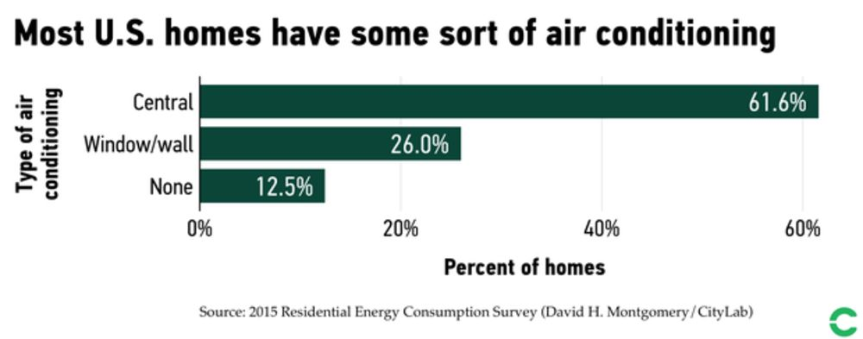

(“8 Charts on How Americans Use Air Conditioning,” [Bloomberg CityLab](https://www.bloomberg.com/news/articles/2019-07-10/why-we-always-fight-over-air-conditioning), 7/10/19)

**“For summer 2021, [The U.S. Energy Information Administration] forecast that total U.S. retail sales of electricity to end-use customers will be 1.5% higher than last summer, primarily driven by increased demand in the commercial and industrial sectors.”** (“Short-Term Energy Outlook Supplement: Summer 2021 Electricity Industry Outlook,” [U.S. Energy Information Administration](https://www.eia.gov/outlooks/steo/special/summer/2021_summer_electricity.pdf), 5/21)

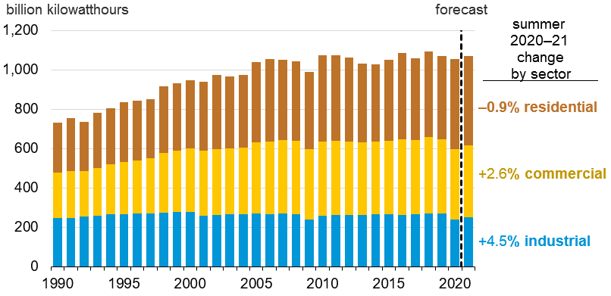

(“Short-Term Energy Outlook Supplement: Summer 2021 Electricity Industry Outlook,” [U.S. Energy Information Administration](https://www.eia.gov/outlooks/steo/special/summer/2021_summer_electricity.pdf), 5/21)

**Between June and August 2020, residential electricity sales and consumption reach record-setting heights, “partially because of the near-record warm temperatures last summer, but also because more people were working from home and generally spending more time in their homes as a result of stay-at-home orders and social distancing guidelines.”** “In contrast to the sharp drop in electricity consumption in the U.S. commercial and industrial sectors last year, residential electricity sales totaled 457 billion kWh between June and August 2020, which was the most on record for that period. Residential electricity consumption reached a record last year, partially because of the near-record warm temperatures last summer, but also because more people were working from home and generally spending more time in their homes as a result of stay-at-home orders and social distancing guidelines.” (“Short-Term Energy Outlook Supplement: Summer 2021 Electricity Industry Outlook,” [U.S. Energy Information Administration](https://www.eia.gov/outlooks/steo/special/summer/2021_summer_electricity.pdf), 5/21)

***Grilling And Cooking***

**In 2020, 68% of American grill owners planned to cook out on the Fourth of July.** “68% of American grill owners plan to cook out on the Fourth of July. The next most popular grilling days are: - Memorial Day (56%). - Labor Day (56%). - Father’s Day (42%). - Mother’s Day (29%).” (“2020 State of the Barbecue Industry,” [Hearth, Patio & Barbeque Association](https://www.hpba.org/Resources/PressRoom/ID/1911/2020-State-of-the-Barbecue-Industry), 4/23/20)

**In a fun study based on hot dog and hamburger consumption on July 4, BTU Analytics estimated that there is approximately a 9,500 additional barrel demand for propane just for Fourth of July grilling.** “However, grills are heating up now that my favorite holiday of the year is upon us. In a country of nearly 330 million people, there are bound to be millions of hot dogs and hamburgers cooking in the summer sun. According to the National Hot Dog and Sausage Council, which oddly has no opinion on whether hotdogs are a sandwich or not, 150 million hot dogs will be cooked on Independence Day tomorrow. If we assume that just as many hamburgers are cooked as hot dogs, but that there is an equal distribution of propane and charcoal grills, there will be approximately 150 million hamburgers and hot dogs cooked on a propane grill. The table below lays out the assumptions to convert 75 million hamburgers and 75 million hot dogs into the additional propane demand that the 4th of July festivities add. If we can cook 10 hamburgers on a mid-sized grill every 10 minutes, that turns into 1.25 million grilling hours. Similarly, at 7 minutes per hot dog and 20 hot dogs at a time, 75 million hot dogs will take 437,500 hours to grill. We also assume that a typical 20-lb propane tank, which holds 4.7 gallons of propane, can grill for 20 hours. This results in an additional 9,442 barrels of additional propane demand from the 4th of July grilling.” (Matt Hagerty, “Propane Prices to See 4th of July Fireworks?,” [BTU Analytics](https://btuanalytics.com/natural-gas-liquids/propane-prices-to-see-4th-of-july-fireworks/), 7/3/19)

(Matt Hagerty, “Propane Prices to See 4th of July Fireworks?,” [BTU Analytics](https://btuanalytics.com/natural-gas-liquids/propane-prices-to-see-4th-of-july-fireworks/), 7/3/19)

**In 2021, the average American celebrating Fourth of July expected to spend almost $81 on food items alone, for a total of $7.52 billion.** (“Independence Day Data Center,” [National Retail Federation](https://nrf.com/insights/holiday-and-seasonal-trends/independence-day/independence-day-data-center), Accessed 6/23/21)

(“Independence Day Data Center,” [National Retail Federation](https://nrf.com/insights/holiday-and-seasonal-trends/independence-day/independence-day-data-center), Accessed 6/23/21)

(“Independence Day Data Center,” [National Retail Federation](https://nrf.com/insights/holiday-and-seasonal-trends/independence-day/independence-day-data-center), Accessed 6/23/21)

**In 2020, the average American celebrating Fourth of July spent over $75 on food items alone, for a total of $6.52 billion.** (“Independence Day Data Center,” [National Retail Federation](https://nrf.com/insights/holiday-and-seasonal-trends/independence-day/independence-day-data-center), Accessed 6/14/21)

(“Independence Day Data Center,” [National Retail Federation](https://nrf.com/insights/holiday-and-seasonal-trends/independence-day/independence-day-data-center), Accessed 6/14/21)

(“Independence Day Data Center,” [National Retail Federation](https://nrf.com/insights/holiday-and-seasonal-trends/independence-day/independence-day-data-center), Accessed 6/14/21)

**In 2020, 64 percent of U.S. adults owned a grill or smoker.** “Almost two-thirds (64%) of U.S. adults own a grill or smoker. More than seven in 10 (72%) Canadian adults own a grill or smoker.” (“2020 State of the Barbecue Industry,” [Hearth, Patio & Barbeque Association](https://www.hpba.org/Resources/PressRoom/ID/1911/2020-State-of-the-Barbecue-Industry), 4/23/20)

**“Gas remains the most popular fuel, with 61% of grill owners using propane, followed by charcoal (49%).”** “Gas remains the most popular fuel, with 61% of grill owners using propane, followed by charcoal (49%), which has increased slightly since 2017 (45%).” (“2020 State of the Barbecue Industry,” [Hearth, Patio & Barbeque Association](https://www.hpba.org/Resources/PressRoom/ID/1911/2020-State-of-the-Barbecue-Industry), 4/23/20)